

***S4***

**Inglés para empresas bajo el modelo de proyección triangular**

**Guía Didáctica y Manual del Curso**

***Oxbridge* ®**

902 500 100 Numancia, 47 Entlo. 2ª. 08029 Barcelona. [www.oxbridge.es](http://www.oxbridge.es/)

GUÍA DIDACTICA

Curso a distancia - English structures in use

**Introducción**

El manual que tienes en tus manos está diseñado bajo el modelo de Proyección Triangular perteneciente al sistema Oxbridge de enseñanza de inglés. Está especialmente concebido como herramienta de consulta, aprendizaje y refuerzo o repaso de las estructuras de la lengua inglesa. Su enfoque funcional, con gran variedad de prácticos ejemplos del uso de las estructuras gramaticales del inglés, permite que se utilice como manual de estudio apropiado para los cursos de distancia ofrecidos bajo el sistema Oxbridge.

El manual está formado por unidades didácticas que giran en torno a un concepto gramatical, acompañado por una explicación de su uso y las situaciones comunicativas más frecuentes donde podemos encontrarlo. El enfoque permite que sea fácil de entender, ya que prima el uso práctico de la estructura en su contexto más común, acompañado por múltiples ejemplos e imágenes que la ilustran y ayudan a la comprensión y a su memorización. Teniendo en cuenta que cualquier estudio personal consta de un fuerte componente de repetición y repaso de contenidos ya aprendidos, el presente manual sirve también como una excelente guía de referencia y consulta, una vez aprendidos los contenidos concretos.

La manera de uso recomendada es leer la explicación de la estructura, entender bien e intentar memorizar los ejemplos ofrecidos y, en caso de duda, llamar al teléfono de consulta de Oxbridge donde un tutor podrá resolver todas las dudas al respecto y poner en práctica lo aprendido. El horario de tutoría es de lunes a viernes de 10 a 14 horas y el teléfono de contacto es el 902 500 100, o bien a cualquier hora mediante la página web o el mai[l oxmail@oxbridge.es.](mailto:oxmail@oxbridge.es)

Una vez completado un nivel, se hará un control de aprendizaje tipo test para comprobar el nivel de adquisición de las estructuras de la lengua inglesa. La necesidad de un test se justifica por la propia necesidad de cualquier alumno a comprobar el grado de retención de los contenidos, sobre todo cuando acomete tal proceso a distancia. Este tipo de pruebas nos permiten saber dónde nos encontramos en el proceso de aprendizaje y cuál es el siguiente paso que tenemos de dar. Para ello, y al final del curso o cuando Ud. considere que se sienta preparado, rogamos que conteste el Control de Aprendizaje que adjuntamos a esta Guía, de la siguiente manera:

1.- Enviándonos vía correo el Control de aprendizaje una vez cumplimentado.

2.- Llamándonos al nº 902 500 100 para realizarlo oralmente por teléfono,

3.- Contestando a través de la web Oxbridge entrando con su contraseña y password.

4.- Realizándolo verbalmente con el Tutor/a en el caso de haber contratado también clases presénciales.

El/los tutores evaluarán sus conocimientos y podrán determinarle el nivel y aprovechamiento alcanzado.

**Qué es la gramática de una lengua y por qué es importante conocerla bien.**

Entendemos por gramática de una lengua todas las estructuras, que revisten a las palabras de sentido y aportan coherencia al mensaje que se quiere transmitir. Es la manera de construir las frases para un significado completo. La distinta manera de combinar palabras en unidades mayores de significado (frases, oraciones). Todas las reglas que rigen y manipulan dicha combinación es lo que entendemos por gramática de una lengua. Así, podemos decir que un estudiante que “sabe gramática” es el que ha adquirido y sabe aplicar correctamente estas reglas para transmitir un mensaje determinado considerado aceptable en la lengua que se estudia. Es indudable que cualquier tipo de conocimiento lingüístico, explícito o implícito, requiere el correcto conocimiento y utilización de las estructuras. No podríamos utilizar las palabras correctamente a menos que las revistamos de las estructuras necesarias para un mensaje inteligible. La gramática nunca es un fin en sí, pero sí es un soporte necesario que se tiene que dominar si pretendemos hacernos entender en otra lengua.

A la hora de organizar y planificar un curso de gramática tenemos que tener muy en cuenta la finalidad de tal empresa. Qué tenemos que incluir en un curso, habida cuenta que las estructuras gramaticales tienen distinto grado de dificultad pero, a diferencia de las ciencias exactas, a veces resulta complicado graduarlas y podemos encontrarlas mezcladas en contenidos tanto para principiantes como para usuarios competentes. Una misma estructura se puede utilizar a niveles bajos y altos para los fines comunicativos y sí es posible aprender estructuras más complicadas a niveles más bajos. Un ejemplo: la voz pasiva es una estructura que normalmente se relaciona con un cierto nivel de conocimiento y utilización del inglés. Si decimos *“The monument had been build a century ago.”* presuponemos unos conocimientos equivalentes a un nivel intermedio de utilización del inglés. Sin embargo la misma estructura está presente incluso en las primeras clases de inglés de unidades para principiantes, por ejemplo en frases como *“The dog is called Bobby”.* Cómo fijar los límites de lo que se ha de incluir en cada nivel, pues. La manera que hemos escogido en el presente manual es fijando un punto imaginario en el que situaríamos a una persona y formaríamos a su alrededor un círculo en el que analizamos sus necesidades comunicativas más inmediatas: el poder hablar de uno mismo, de su casa, su familia, su trabajo, sus necesidades básicas, su tiempo libre, etc. Analizando qué estructuras participan de este círculo de necesidades comunicativas, estableceríamos aquellas estructuras que han de cubrirse obligatoriamente a este nivel. Con cada nivel superior ensancharíamos el círculo comunicativo para añadir más posibilidades lingüísticas, cada vez más complejas y ricas en matices.

**Equivalencia entre los niveles Oxbridge y el Marco Común Europeo para la**

**Referencia de las Lenguas (MCERL)**

Los niveles utilizados en Oxbridge para definir el grado de dificultad de las estructuras gramaticales y el nivel al que es más conveniente presentarlas, se corresponden a los siguientes niveles del Marco Europeo:

|  |  |  |
| --- | --- | --- |
| Niveles  Oxbridge | Nivel de utilización del inglés | MCERL |
| S1  S2  S3  S4  S5 | principiante elemental intermedio bajo intermedio alto avanzado | A1 – usuario básico, acceso  A2 – usuario básico, plataforma  B1 – usuario independiente, umbral  B2 – usuario independiente, intermedio alto  C1 y C2 – usuario competente: dominio operativo |

eficaz y maestría

**Manual del Curso**

**CONTENTS**

S4.08.04. Compound adjectives-a good looking man, blue eyed girl

S4.08.05. Adjectives and participles with -ed-ing

S4.08.06. Order of adjectives

S4.09.05. Internsifiers in comparison- much a lot of far bigger much more far less. The ... the (the sooner the better)

S4.11.04. Future continuous--forms and use

S4.11.05. Future perfect--forms and use

S4.12.12. The past perfect simple and continuous S4.12.13. Past habits- used to, would, be-get used to S4.12.14. Tag questions in all tenses and auxiliaries

S4.12.15. Short answers and reply questions (all tenses and auxiliaries)

S4.14.04. Past modal verbs S4.14.05. Need -ing Needn't S4.16.05. Third conditional

S4.16.06. Wishes about the present and the past--if only...--I wish1

S4.17.04. The passive voice--perfect and continuous tenses

S4.18.04. Describing a sequence of events 'when as soon as as while just as until'

S4.18.05. Reported speech with and without tense change—

statements

S4.18.06. Reported speech- orders, comands and requests

S4.18.07. Reporting verbs

S4.18.08. Reported speech.Yes and No and wh questions S4.18.12. Reported speech with modals and conditionals S4.19.04. Homonyms and homophones

S4.19.05. Syllable stress in compund nouns adjectives. Change in stress in nouns and verbs with the same root

S4.19.07. Opposite or negative meanings with prefixes

S4.19.08. Word formation using suffixes

Writing Emails

What do the words SIX-SIDED FIGURE, BIG-EYED CAT and COLD-HEARTED MAN have in common?



**A six-sided figure A big-eyed cat**

They are all compound adjectives formed from nouns to give physical or metaphorical description.

So, instead of saying “The figure has 6 sides” we turn the sentence into “It is a six-sided figure”.

The structure is as follows:

S + HAVE / HAS + NOUN PHRASE SUBJ + BE + ADJECTIVE + NOUN



+ ED + NOUN Eg.

The stool has three legs. It is a three-legged stool.

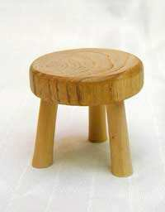

Mary has long hair. Mary is a long-haired beauty.



The soldiers have brown helmets. They are brown-helmeted soldiers. The animal has three legs. It is a three-legged animal.



NOTE: This is only possible only if HAVE is used to indicate a part of the whole, not possession of something separate!!!

E.g.:

* Mary has two cars. Mary is a two-carred housewife. INCORRECT!!



* Mary has two sons. Mary is a two-sonned mother. INCORRECT!!



How do you usually feel after a **relaxing** bath? Usually, we feel **relaxed.** And after a **tiring** working day? Probably **tired.** This is an example of how we can use participles in order to express characteristics.

With some verbs, when we describe the feeling that something has on somebody’s feelings, we use –ING participle. Eg.

My bath was relaxING. (to describe how the bath was, we focus more on the process)

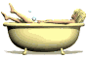

When we express the feeling of the receiver, we use –ED participle.

I feel relaxED now. (to describe the way I feel now, we focus more on the result)

I feel relaxed after a relaxing bath.

More examples:

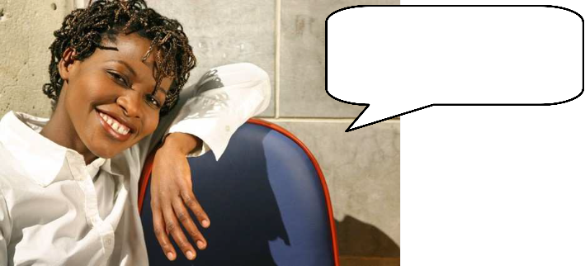

1) The clown was entertainING

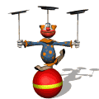

The family was entertainED. (to describe the way they felt)

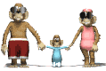

2) The scenes in the movie were so touchING. (to describe how the movie was)

I was so touchED by the movie. (to describe the way I felt)



3) The nurse came in with a big needle. It was scarING. I was scarED when she walked over to me.



4) Ted forgot to zip his zipper. It was really embarrassing. Ted felt really embarrassED.



5) The dog was scarING. I got scarED of the dog.



6) The footprint was very interestING. The detective was very interestED in the footprint.



More examples we can use are:

The cause of the feeling The receiver of the feeling is:

**alarming alarmed amusing amused boring bored concerning concerned confusing confused embarrassing embarrassed encouraging encouraged entertaining entertained exciting excited exhausting exhausted frightening frightened frustrating frustrated interesting interested overwhelming overwhelmed pleasing pleased relaxing relaxed satisfying satisfied shocking shocked surprising surprised terrifying terrified**

**tiring tired**

Do you want to know how to describe the way objects or people are? That is, to express their characteristics, qualities, etc.? Then you need to use adjectives, and sometimes you need to use more than one.

The most important thing to have in mind in the order of adjectives is that, unlike in Spanish, the adjective goes **before** the noun. E.g.: a beautiful dress, not *a dress beautiful (incorrect).*

**Important:** The more we want **to precise** the noun the more adjectives we add. When we have more than one adjective before a noun, this is the order they

must follow within the sentence:

1. Opinion

2. Size

3. Age

4. Shape

5. Colour

6. Origin

7. Material

8. Purpose

**A beautiful young Spanish woman.**

A young Spanish beautiful woman. (incorrect!)



A lovely, large, old, round, brown, British, wooden, dining table.



An nice large new green English polyester rain coat.

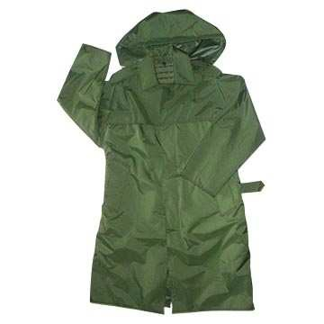

**Difficult? No worries, it’s not very common to have such a long list of adjectives in everyday language.**

This table explains the order of adjectives coming before a noun in the English language, although it is very unlikely that anyone would use eight adjectives before a single noun. Generally, few would use more than a couple or so. There are cases where the order isn't followed, but it works in almost all cases. The basic movement is from subjective (opinion) to objective (material/purpose).

|  |  |  |  |  |  |  |  |  |
| --- | --- | --- | --- | --- | --- | --- | --- | --- |
| Opinion | Size | Age | Shape | Colour | Origin | Material | Purpose | + Noun |
| good bad terrible | huge tiny vast | young elderly ancient | round square circular | black white transparent | Spanish Japanese British | leather plastic metal | riding sleeping hunting | boots bag rifle |

When we speak, we often need to **emphasize some qualities**, in order to achieve expressiveness and reinforce the ideas or characteristics of the what you describe or compare.

Compare: My house is **bigger** than yours. (neutral statement) Vs. My house is **far bigger** than yours. (reinforced idea)

The dimension of the house in the second sentence is clearly reinforced and it is much more expressive than the first one.

This structure is commonly know as intensifiers. In this case, we are dealing with intensifiers of comparisons, which are useful when you want to compare two things that may or may not be similar, but you want to make it clear that one of them is much more bigger, smaller, etc.

Nothing changes, just add one word and you got it.

The intensifier usually goes before the adjective or adverb.

**\*Please note:** when you are using an a long adjective (2+ syllables) the adjective stays the same and you don’t add –er.

Here are some of the most common comparison intensifiers:

- Much

- More

- A lot of

- Far bigger

- Far smaller

- Much more

- Far less

- Way

- Etc.

Here are some examples of these intensifiers of comparison in use:

1) I have MUCH money, and you don’t.



Money, money, moooneeeyyy!

2) She is MUCH MORE beautiful than her.

vs.



3) They have A LOT OF love for each other, but we don’t.

vs.



4) The USA is FAR BIGGER than Spain.

vs.

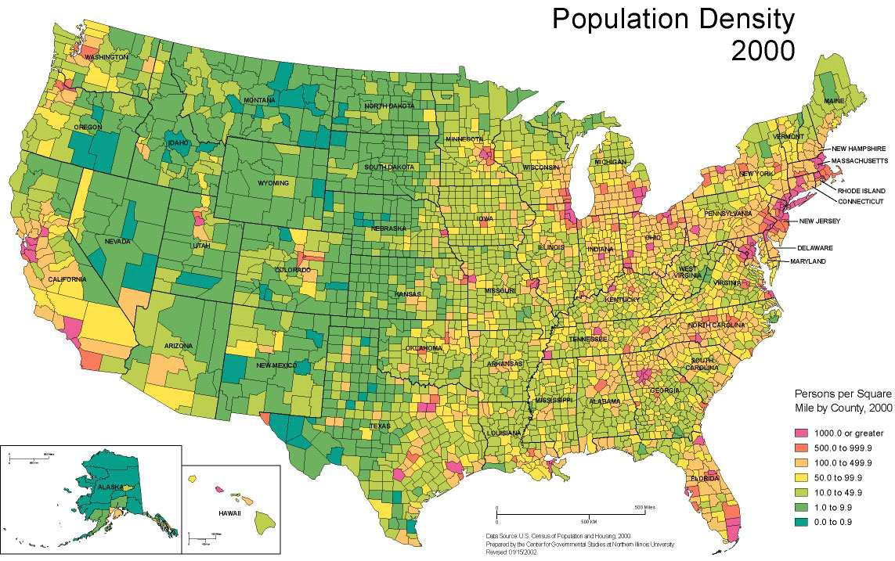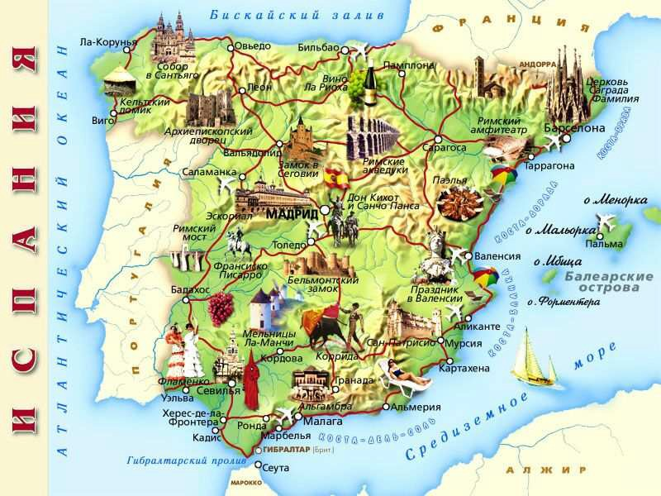

5) The mouse is FAR SMALLER than the hamster.

vs.

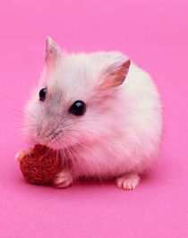

6) We are MUCH MORE intelligent than him.

vs

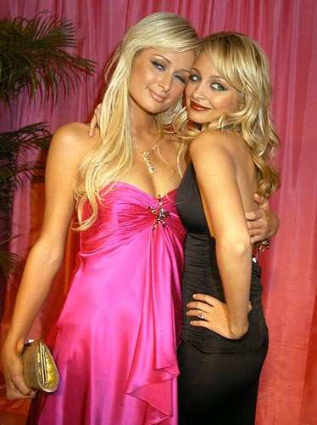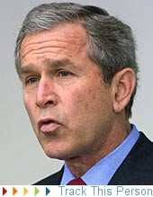

7) She is MUCH MORE charming than her.

vs.



8) He is FAR LESS brave than him.

vs.

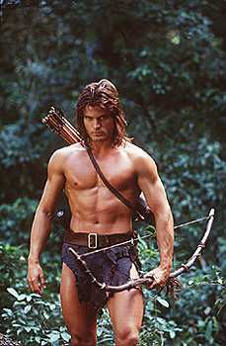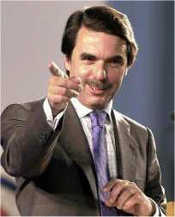

9) That house is WAY more expensive… …than this.

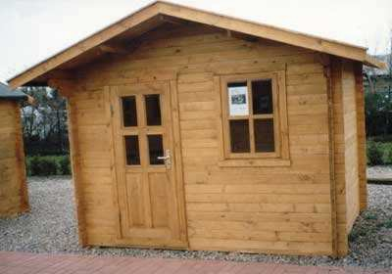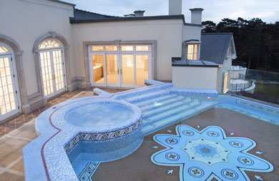

There are more words which can be used to 'intensify' many adjectives – 'very'

'really' 'totally' 'absolutely' 'completely' 'utterly' 'entirely'.

· It's very tall.

· We're really happy.

· She's totally exhausted.

· I'm absolutely horrified.

· He's completely hopeless.

· You look utterly miserable.

· I'm entirely satisfied.

Certain adjectives have their own 'special' intensifiers which are often used with them. Here are some common ones:

blind drunk

· He was blind drunk and behaved really badly.

bone dry

· I must have a drink. I'm bone dry.

brand new

· I've just bought a brand new car.

crystal clear

· The sea near Rhodes is crystal clear.

dead easy

· That exam was dead easy. I've certainly passed.

dead lucky

· He's won three lottery prizes this year. He's dead lucky.

dead right

· I agree entirely. You are dead right.

dirt cheap

· I bought my car for a dirt cheap price from an old lady who had hardly driven it.

fast asleep / sound asleep

· I was in bed and fast asleep by nine.

· I was sound asleep and I didn't hear anything.

paper thin

· These office walls are paper thin. You can hear everything said in the next office.

pitch black

· There's no moon. It's pitch black out there.

razor sharp

· Be careful with that knife- it's razor sharp.

rock hard

· It's impossible to dig this soil – it's rock hard.

stark naked

· The hotel door slammed behind me and I was left standing stark naked in the middle of the corridor.

stone deaf

· He can't hear a thing. He's stone deaf.

wide awake

· I was wide awake by six.

wide open

· Who left the door wide open?

THE SOONER THE BETTER

To say that as one thing changes, another thing also changes, we can use sentences like:

- The better the joke (is), the lauder the laugh (is).

- The longer Sue stays in Canada, the less likely she will ever go back to England.

- It almost seems that the more expensive the wedding, the shorter the marriage!

Students: Do you need to express something that will take place in the **future** and you know it’ll be an **action in progress** or with a continuous duration for a certain period of time? Then pay attention to the structure below. It will be useful for you to express exactly this: **a continuous action in the future**.

Imagine that you are doing something at that very moment: let’s say the laundry. You would say something like: “I’m doing the laundry now.” Now imagine that at the same time one week later you plan to do the same. You would say something like “This time next week **I will be doing** the laundry again.” Well, this is how it works.

We use the future continuous when we intend or plan to do something at a specific time in the future.



Form:

Affirmative: S + Will + be + V - ing Negative: S+ Won't + be + V -ing Interrogative: Will + S + be + V -ing?

Usage:

When we talk about an activity or event going on at a PARTICULAR TIME or over a PARTICULAR PERIOD in the future. Note that you need to **specify the time** that action is going to take place. For example:

I will be picking him up at the airport this afternoon.



I’m lost!

El Prat, BCN

I will be flying to England tomorrow at 8 o’clock. The plane will be travelling at twice the speed of sound when it passes overhead.

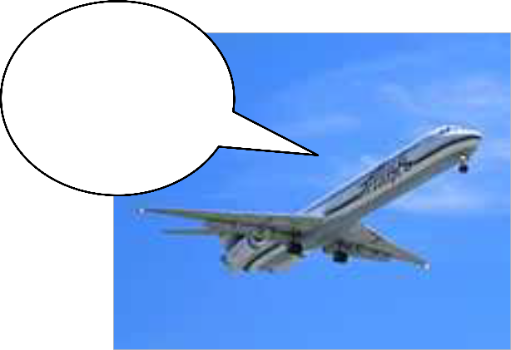

England!?!? Not during the summer, noooooo…

Here are some more examples (affirmative, negative, and interrogative):

1) He will be jogging next week.

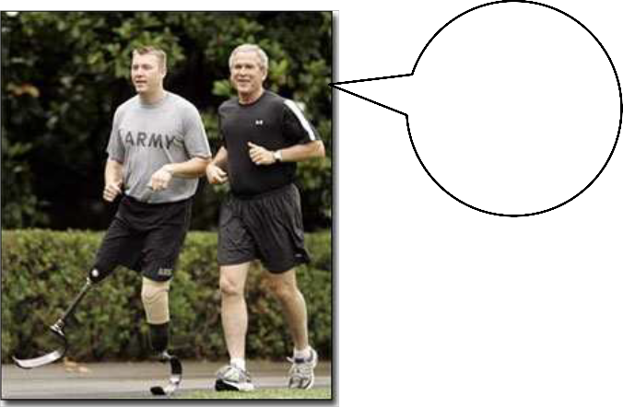

Hey mate, can I

borrow your leg? I’m tired.

2) I will be having a party this evening.

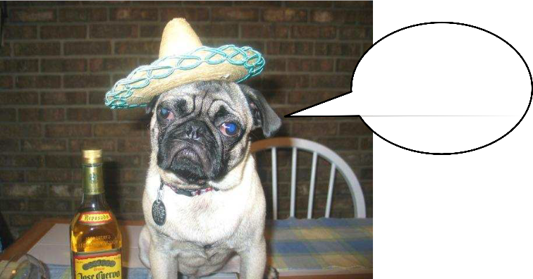

Help! I can’t drink anymore.…

3) She won’t be going to go to Australia next month.

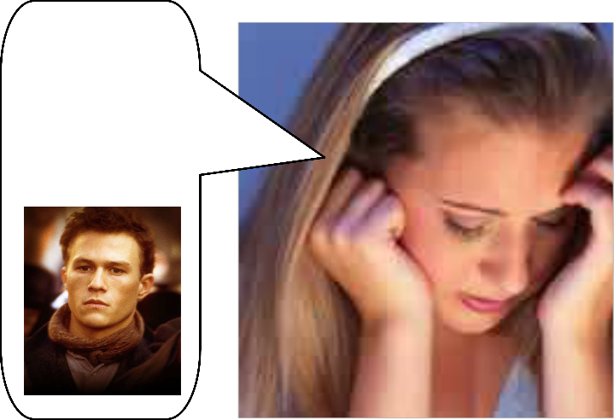

I will miss you my beautiful Australian, Health Ledger

4) We won’t be leaving at 7:30 PM.

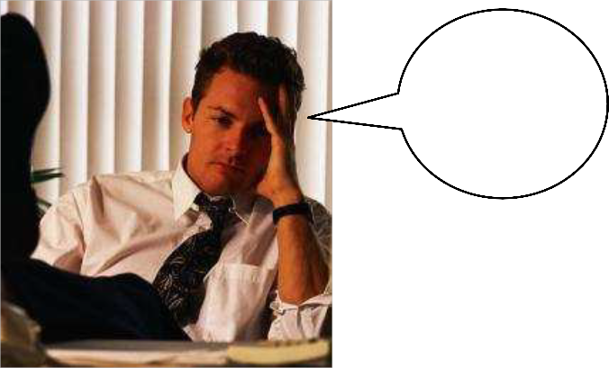

I am so tired and annoyed!

5) What will they be doing next weekend at that same hour? They will be going to

Disneyland.

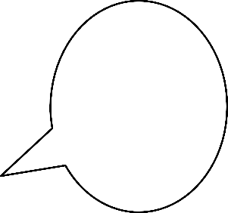

Dad: you are such a nerd. Get out of the picture.

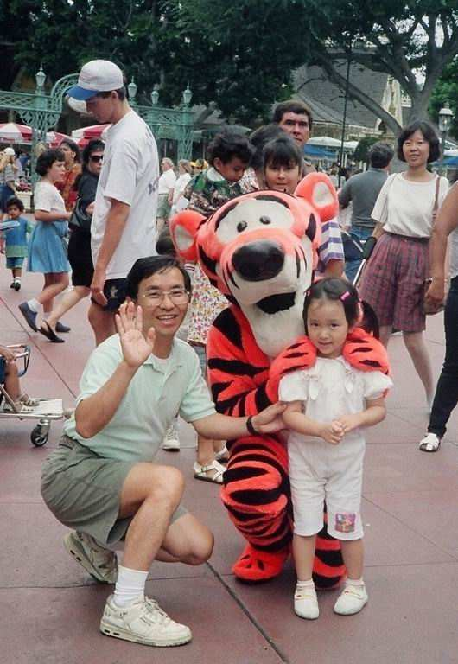

6) What will you be doing tomorrow morning? I’m going to the dentist.

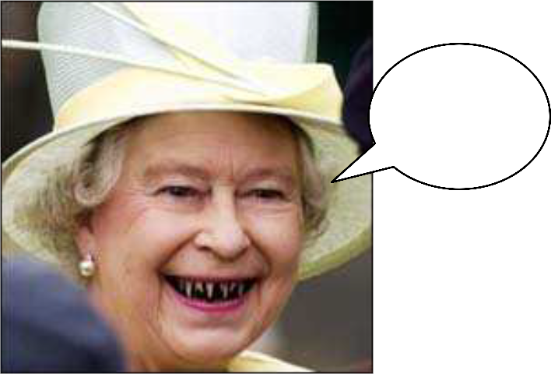

I hope he can help me ☺

Students: When we need to express the idea that something will occur before another action in the future or when we need to show that something will happen before a specific time in the future, we do it by means of the structure below. In this case, we need to **specify** the period of time the future action will have taken place.

Imagine that you want to say that today you have eaten 2 toasts. And tomorrow you want to eat 2 more. That means that in two days time **you will have eaten** four toasts. And this is how it works.

As this structure expresses an action taking place in the future, we can’t use it in clauses beginning with "when," "while," "before," "after," "by the time," "as soon as," "if" and "unless".

EXAMPLES:

I am going to see a movie when I have finished my homework. Correct

I am going to see a movie when I will have finished my homework. Not Correct

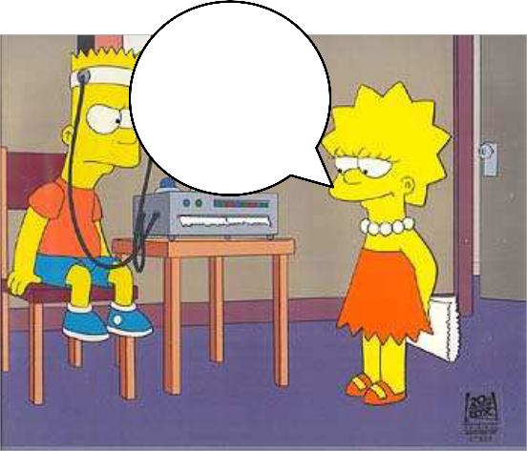

Remember

, if we don’t finish you cant watch the movie.

Here you have the form of the Future Perfect: **[WILL HAVE] + [PAST PARTICIPLE]** EXAMPLE:

I will have improved my English by the time I come back from the U.S.

My English much better than you, jajajaj…

**[AM / IS / ARE] + [GOING TO HAVE] + [PAST PARTICIPLE]**

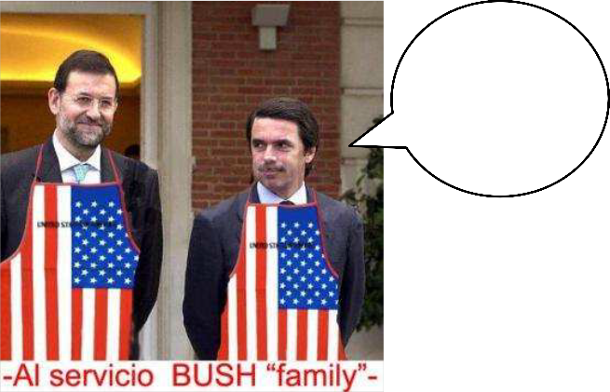

EXAMPLE:

I am going to have perfected my English by the time I come back from the US. NOTE: It is possible to use either "will" or "going to" to create the Future Perfect with

little or no difference in meaning.

Below you will find the uses of the Future Perfect:

**USE 1** Completed Action Before



Something in the Future

EXAMPLES:

By next November, I will have received my promotion.

I really need that extra money to buy a new wardrobe!

By the time he gets home, she is going to have cleaned the entire house.

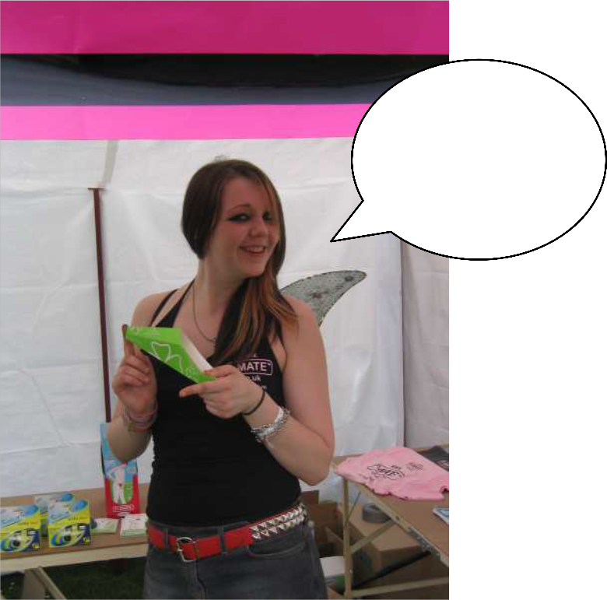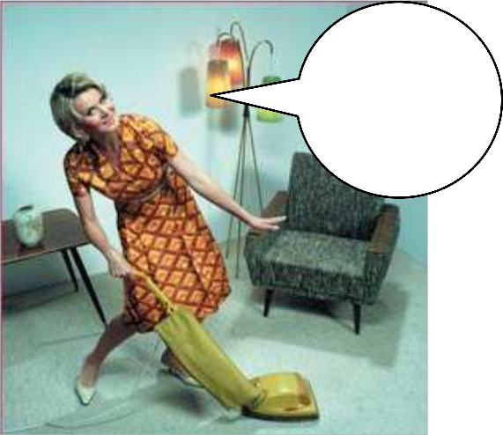

I am going crazy cleaning this fu#@*&@ho use!

**USE 2** Duration Before Something in the



Future (Non-continuous Verbs)

With Non-continuous Verbs and some non-continuous uses of Mixed Verbs, we use the

Future Perfect to show that something will continue up until another action in the future. EXAMPLES:

I will have been in London for six months by the time I leave.

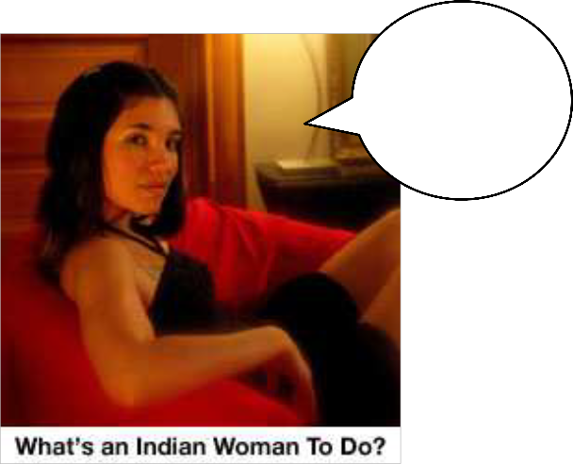

I will

come back soon! ☺

By Monday, Susan is going to have had my book for a week.

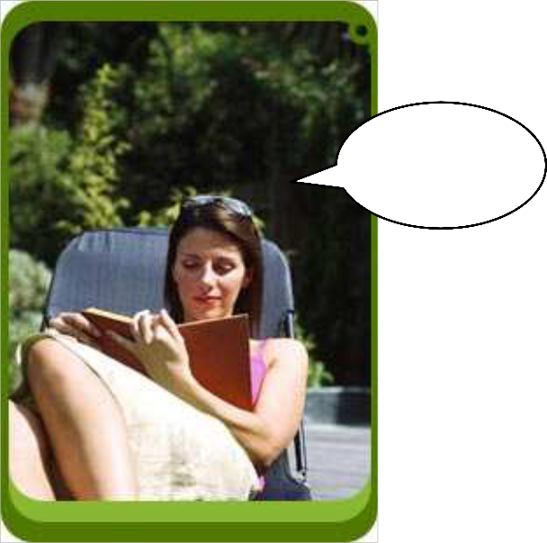

Page 1….

Here you have a structure that sometimes is difficult for some non-native English speakers. Please read through the information provided and the examples given.

You will learn how to refer to past event that happened BEFORE another past event, both for continuous (ongoing) and non-continuous actions or states.

These two past forms are complex forms. As a reference they take a moment in the past and tell us that something happened even before that past time.

Let’s see how it works:

When we need to make clear that one event in the past happened before another event in the past, we use:

Affirmative: S+ had + past participle + rest of the sentence Negative: S + hadn't + past participle + rest of the sentence Interrogative: Had + S + past participle + rest of the sentence?

She had heard the news before I saw her.

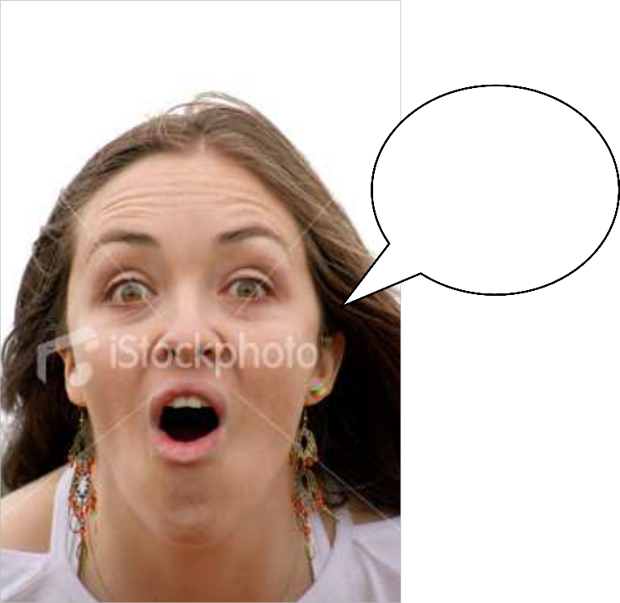

Oh my god! I can’t believe it! I’m going to tell …

I hadn’t finished dancing by the time the clock struck twelve.

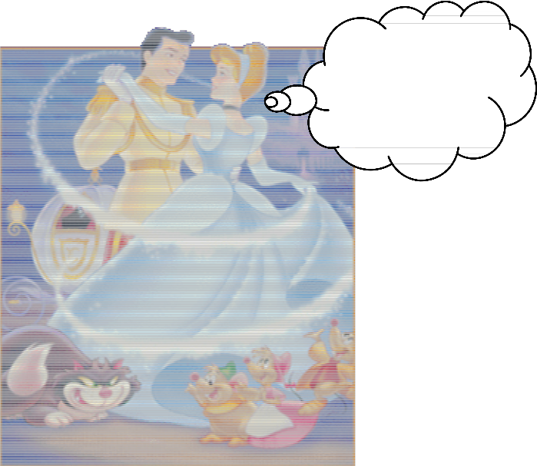

Sorry darling, I need to run

☺

Had they started working before their boss returned?

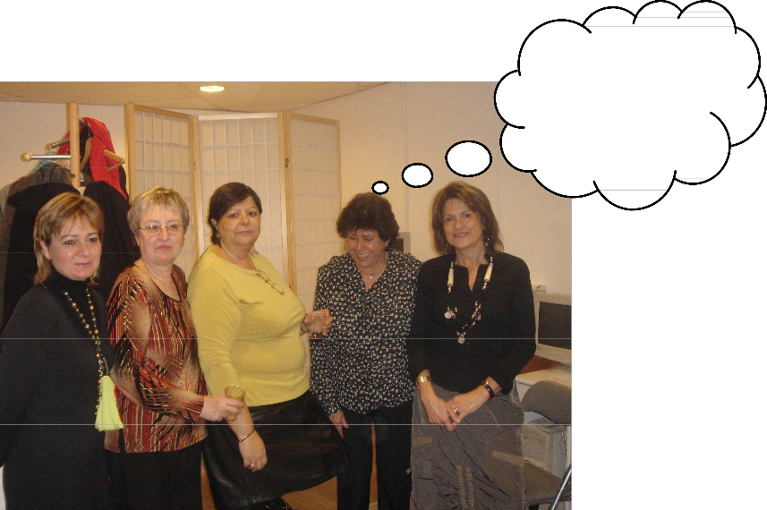

It wasn’t us, we swear! Jejejejje ☺

Now, the same idea of two actions in the past, being the first one a continuous one and the other a completed one, can be expressed by a similar structure. All we need is to reinforce the idea of the progress of the first action.

In other words, we have a continuous action in the past which was already completed by the time another action in the past took place.

See the following examples, where this structure is underlined.

I had been waiting for two months by the time I received the reply.

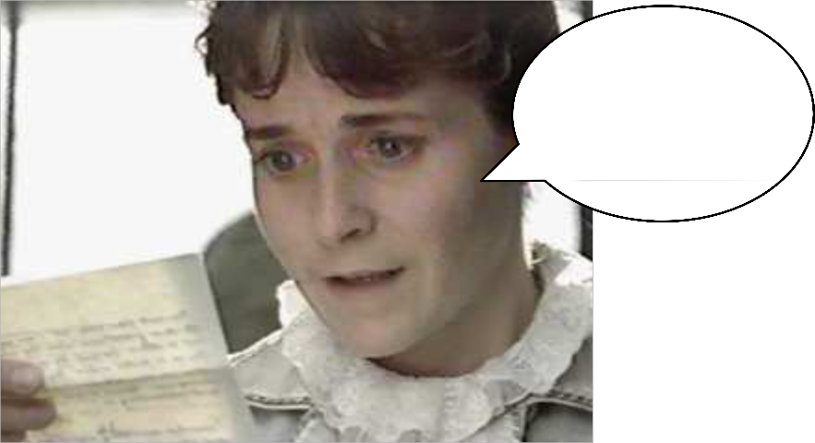

Nooooo…it can’t be possible!

He hadn’t been thinking about his girlfriend shortly before she arrived.

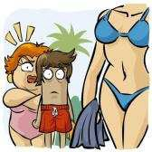

**Form:**

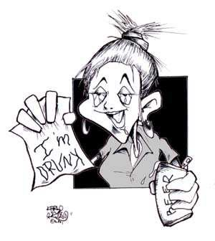

Had she been drinking before the party started?

Affirmative: S + had + been + V + ing + C Negative: S + hadn’t + been + V + ing + C Interrogative: Had + S + been + V + ing + C?

How do you express a habit you had in the past or a situation that existed but that no longer exists?

USED TO + infinitive is used to describe habits we had in the past or situations that existed in the past but that no longer exist.

Eg. I used to smoke, but now I don’t even touch a cigarette.

There used to be a church at the top of that hill. (but the church is no longer there)

We used to be so happy together. (= we are not together anymore)

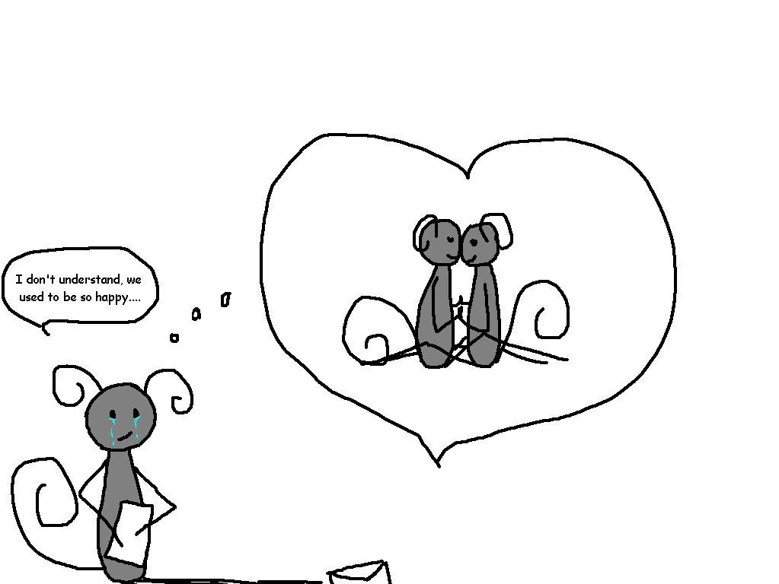

DID NOT/DIDN´T USE TO + infinitive is the negative form

Eg: When I was 10 I didn’t use to go swimming but now I go swimming a lot.

WOULD + infinitive is used to describe repeated actions (not states), usually an activity which was typical of a person.

Eg: When I was a child my father would sometimes take me fishing. (=he used to take me fishing with him.)

GET USED TO + NOUN or verb + -ING and BE USED TO + NOUN or verb +

–ING means to **become used to**, **to acquire a habit**. If somebody **gets** or **is used** to something, he becomes or is fully familiar with it. It is no longer strange

or awkward. It can refer to past, present or future experiences. They can always be replaced by **be** or **become accustomed to** which is very similar in meaning,

if a little more formal.

Eg. Young drivers must get used to driving in heavy traffic as soon as possible. When I first moved to Edinburgh I found it very difficult to understand locals, but

now I’m getting used to the accent.

I never got used to shaking hands with people all the time when I lived there. It’s not the custom in our country.

If you think that English is difficult and want to check if the person you are addressing to agrees with you, you add a short question at the end your statement. EG.

**English is** difficult, **isn’t it?**

This short question is used to verify or check information that we think is true or to check information that we aren't sure is true. Normally a positive statement is followed by a negative tag, and a negative statement is followed by a positive tag. The verb in the statement should be the same tense as the verb in the tag.

Eg. **It was** a very good party, **wasn’t it?** (the meaning is something like: Do you agree that it was a very good party? **or** Will you confirm that it was a very good party?)

**It wasn’t** a very good party, **was it**?

The statement and the tag are always separated by a comma.

Notice that any statements with **nothing, nobody** etc should be treated like negative statements.

Eg. **Nothing** lasts forever, **does it?**

**Nobody** knows, **do** they? (we use *they* to replace *nobody)*

If a modal (can, could, will, should, etc.) is used in the statement, then the same modal is used in the tag part. If the statement doesn't use an auxiliary verb, then the auxiliary *do* is used in the tag part.

The event was really touching, wasn’t it? We had a good time, didn’t we?

**Special cases:**

**Question tags with imperatives**

Sometimes we use question tags with imperatives (invitations, orders), but the sentence remains an imperative and does not require a direct answer. We use *won't* for invitations. We use *can, can't, will, would* for orders.

|  |  |  |
| --- | --- | --- |
| Function | imperative + question tag | *notes:* |
| Invitation | Take a seat, won't you? | polite |
| Order | Help me, can you? | quite friendly |
| Help me, can't you? | quite friendly (some irritation?) |
| Close the door, would you? | quite polite |
| Do it now, will you? | less polite |
| Don't forget, will you? | with negative imperatives only *will* is possible |

**Same-way question tags**

Although the basic structure of tag questions is positive-negative or negative- positive, it is sometime possible to use a positive-positive or negative-negative structure. We use same-way question tags to express interest, surprise, anger etc, and not to make real questions.

So you're having a baby, are you? That's wonderful! She wants to marry him, does she? Some chance! So you think that's amusing, do you? Think again.

Negative-negative tag questions usually sound rather hostile: So you don't like my looks, don't you?

**More special cases:**

With suggestions, we use *shall: Let’s go,* ***shall we?***

I **am** right, **are**n't I? (not *amn’t I)*

You **have** to go, **don’t** you? (not *haven’t you)*

He**'d** better do it, **had**n't he?

**Intonation**

We can change the meaning of a tag question with the musical pitch of our voice. With rising intonation, it sounds like a real question. But if our intonation falls, it sounds more like a statement that doesn't require a real answer:

|  |  |  |  |
| --- | --- | --- | --- |
|  | intonation | |  |
| You don't know where my wallet is, | do you? | / rising | real question |
| It's a beautiful view, | isn't it? | \ falling | not a real question |

**Answers to tag questions**

How do we answer a tag question? Often, we just say Yes or No. Sometimes we may repeat the tag and reverse it (..., do they? Yes, they do). Be very careful about answering tag questions. In some languages, an opposite system of answering is used, and non-native English speakers sometimes answer in the wrong way. This can lead to a lot of confusion!

For example, everyone knows that snow is white. Look at these questions, and the correct answers:

|  |  |  |  |
| --- | --- | --- | --- |
| tag question | correct answer |  |  |
| Snow is white, isn't it? | Yes (it is). | the answer is the same in both cases - because snow IS WHITE! | but notice the change of stress when the answerer does not agree with the questioner |
| Snow isn't white, is it? | **Yes** it **is**! |
| Snow is black, isn't it? | **No** it **isn't**! | the answer is the same in both cases - because snow IS NOT BLACK! |
| Snow isn't black, is it? | No (it isn't). |

In some languages, people answer a question like "Snow isn't black, is it?" with "Yes" (meaning "Yes, I agree with you"). This is the **wrong answer** in English!

When we talk to somebody and want to express **surprise** with what we heard, one of the structures you can use is the one you have below.

We use the so called *reply questions* when we DON’T AGREE, or we AREN’T SURE, or if we are SURPRISED with what another person says. For example, a reply with something such as: ‘really?’ or ‘is that true?’

This structure should be very easy because it’s simply a short answer (of any kind) and a reply question to that answer. **The tag in the reply question agrees in tense with the main verb it refers to.**

In English we use that structure a lot, you’ve probably heard it in films, series, etc.

Below you will find some examples.

**EXAMPLES:**

- I love to watch the Superman series.

- **Oh! Do you?** (=oh, really?) **I don’t.**

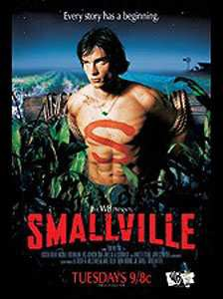

Sexy ☺

- He scored a goal.

- **Did he? (=Is that true?)**

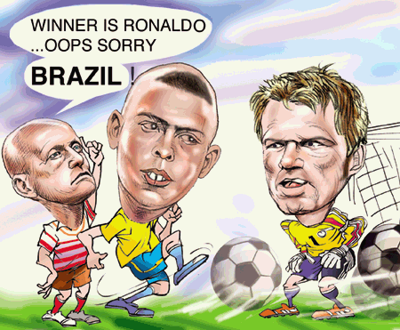

- The book was on hippo’s.

- Was it?

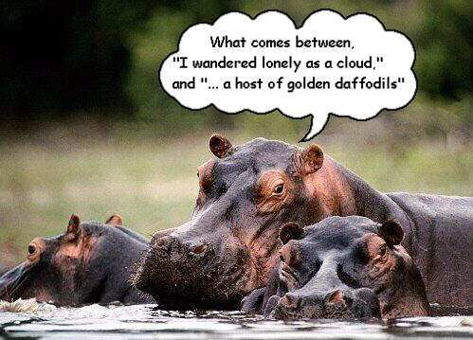

- She has a brain.

- Has she? (=Really?)

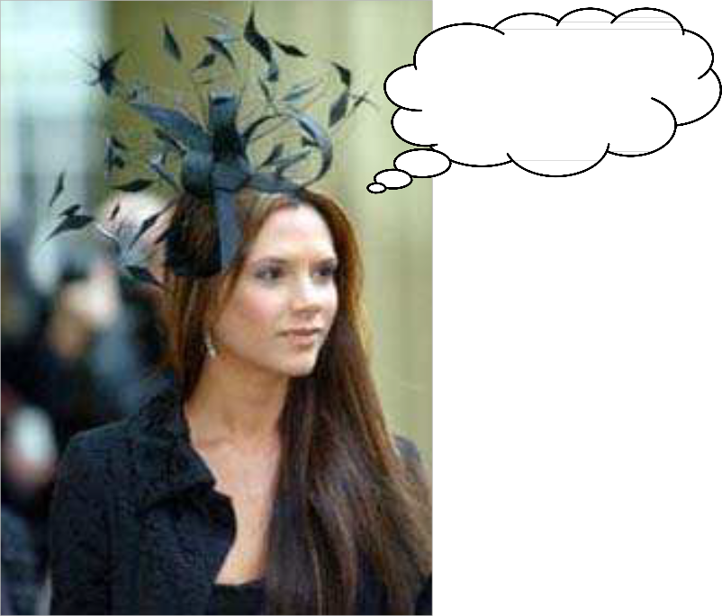

Is that a bird on my head?

- He isn’t smarter than the rest.

- Isn’t he? Is that true? I thought he was different…

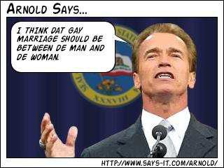

- She loves her boyfriend. I think they will marry.

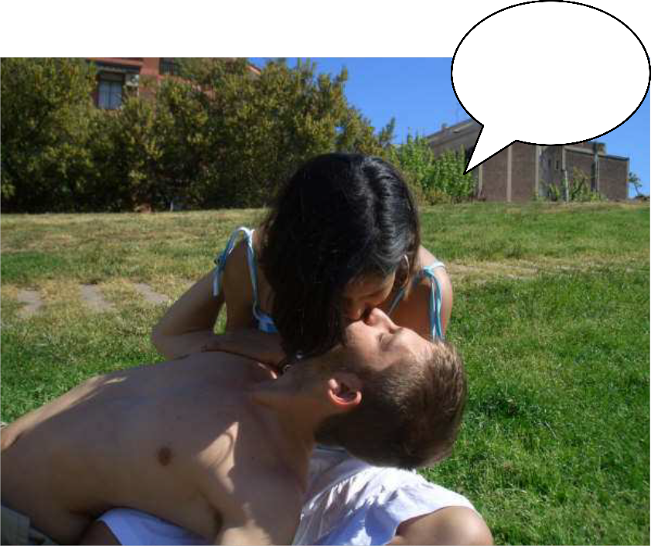

- Oh, does she? Will they???

3 years and going strong!

- They are great friends.

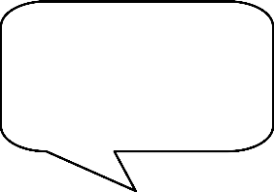

- Are they?

**FUN TIMES!!!**

☺



When we want to express obligation or requirement, recommendation, possibility, option, choice, etc. in the past, we do it with the help of the verbs that express this idea and past forms. What is interesting about this verbs, commonly known as modal verbs, is that the structures that they form are autonomous, that is they don’t need other helpling (auxiliary) verbs to make the interrogative or the negative forms.

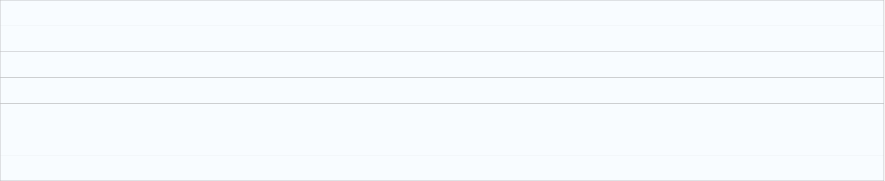

Let’s see how they work:

We use MUST HAVE + PAST PARTICIPLE to say we’re ALMOST CERTAIN something happened in the past, because of the information we have. We use CAN'T HAVE (NOT mustn’t have) + PAST PARTICIPLE to say we think something was impossible.

Ex. It must have sunk immediately. (Nothing was found.)

He can’t have run out of fuel. (Impossible. He had plenty.)

We can use either MAY HAVE, MIGHT HAVE or COULD HAVE + a PAST PARTICIPLE

to say that something POSSIBLE in the past.

Ex. It may have fallen asleep. (= It’s possible it’s fallen asleep.)

It might have gone under the floorboards. (=That’s possible.) It could have gone down the toilet.(=That’s possible.)

COULD HAVE can also mean that something was possible, but DIDN'T HAPPEN.

Ex. I could have given it some food this morning. (He didn’t give it any food.) Note the NEGATIVE FORMS: may not have/ might not (n’t) have.

Ex. I might not have put the cover on.(= It’s possible I didn’t.) COULDN'T HAVE means that something was TOTALLY IMPOSSIBLE.

Ex. A thief couldn’t have got into the house. (= It wasn’t possible.)

We use SHOULD HAVE or OUGHT TO HAVE + a PAST PARTICIPLE to say something in the past was a MISTAKE.

Ex. I shouldn’t have taken the car. (But he took it. It was a mistake.)

You should have been watching the road.(But he wasn’t watching the road.) You oughtn’t to have been eating a hamburger. (But he was eating it).



Note in this case we are dealing with past modal verbs (**could, should, might**), but these are not usually used with a past meaning. One exception is **could** which, when talking about ability, is used as a past form of **can**:

I **could** run a long way when I was younger. (refers to a past event)

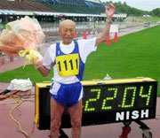

I **could have gone** to Yale University. (refers to the possibility, in the past, of going to Yale, and implies that the person eventually didn’t go to Yale).

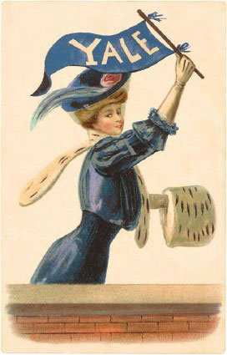

I **may have seen** him yesterday. (I’m not sure it wasn’t him)



You **should have told** me last week. (it was your obligation and you didn’t do it).



But, I love you and not him!

We use **must** to convey strong obligation. The past form of **must** for obligation is **had to**:

*We* ***had to*** *leave the restaurant immediately.*

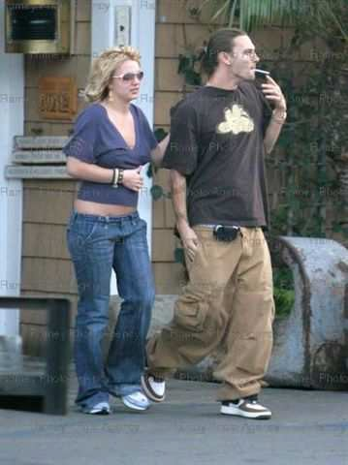

We had no money to pay the bill

We use **should** to convey milder obligation. The past form of **should** for mild obligation is **should have**:

*You* ***should have*** *gone to visit your grandmother.*

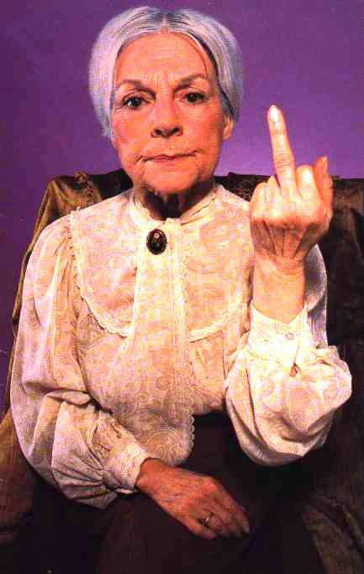

We use **must not** to convey prohibition. The past form of **must not** for prohibition is

**wasn't/weren't allowed to**:

*We* ***weren't allowed to*** *use our mobile phones in the building.*

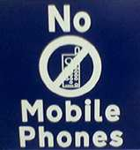

We use **needn't** to talk about a lack of obligation. The past form of **needn't** for lack of obligation is **needn't have**:

*We* ***needn't have*** *mentioned it - they already knew.*

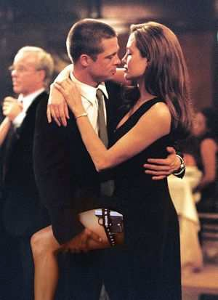

We got married!

We use **may** and **can** to give permission. The past is conveyed by **was/were allowed to**:

*The prisoner was* ***allowed to*** *sit down.*

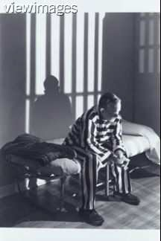

*We* ***were*** *only* ***allowed to*** *smoke with her.*

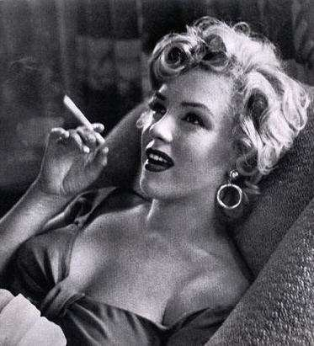

We use **can** to speak about ability. The past form of **can** for ability is **could**:

*She* ***could have*** *played the piano beautifully when she was six, but now she’s awful.*



We use **won't** to say we are not willing to do something. The past form of **won't** is

**wouldn't**:

*He* ***wouldn't*** *promise anything.*

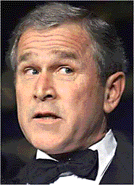

We can use **will** to talk about actions that are habitual. The past form of **will** for typical behavior is **would**:

*He* ***would*** *wash his car every Sunday morning.* (He used to wash the car)

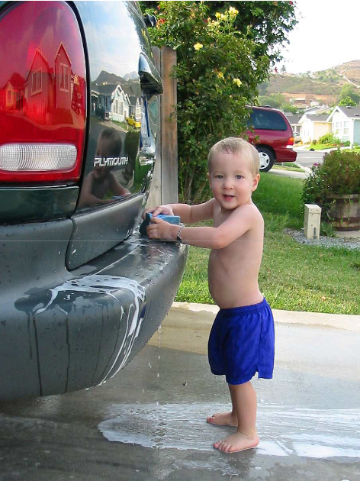

**STUDENTS:** If you have to express a **necessity** in English, here you have a very common and useful structure:

For example:

She **needs** to go shopp**ing** this afternoon.

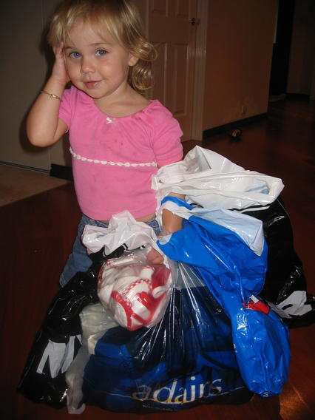

When it is used as an ordinary verb with **to** before the following infinitive and with an **s**

in the third person singular, it appears in both affirmative and negative sentences and in questions:

She's dehydrated. Her body needs drinking some water.



They are not very athletic, their bodies **need** training.

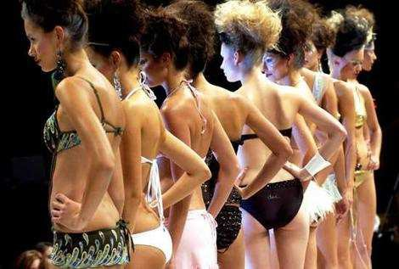

He is 16 he **doesn't need to** be drink**ing** so early.

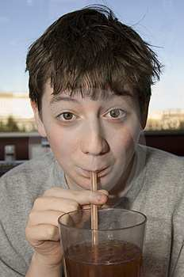

(Beer!?!?!)

Do I **need** to be waiting in line?



(I need to go to the bathroom!)

Please note that in this case, “need” means something that must be done. The structure for it is:

**Subject + need + to be + (verb) –ing // Subject + need + -ing**

**Do/Does + subject + need + (verb) –ing?**

As far as ***needn't,*** it’s used when it’s not necessary to do something. For example:

You **needn't** arrive early. (No need to hurry.)



He **needn’t** do the dishes tonight! (You can do it tomorrow.)

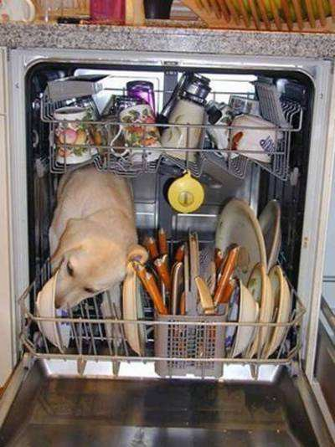

(But I like cleaning them! ☺ )

We **needn’t** have a lot of money to feel rich.

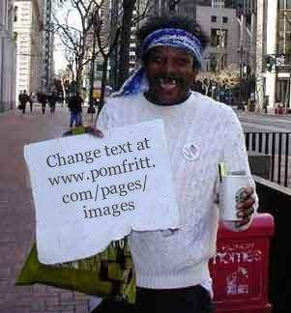

(Hey! Life is good!)

**Needn’t** I go to school?



(Yahoo! I’m going to play with my PlayStation.)

Here you have the structure format: **Subject + needn't + infinitive (w/out ‘to’) Needn’t + Subject + infinitive**



EXPRESSING CONDITIONS: THIRD CONDITIONAL

Many times, when we **regret** something that have happened to us or around us, we wish thing were different. But, as things happened in the past, there is nothing we could do now. Except regretting and imagining the same actions with different result! This is what we call hypothesis. In this hypothetical cases, the results are highly improbable, in fact, we know that what happened is not what we wish could have happened.

When we are talking about situations in the past that cannot be changed and we are imaging something different from what actually happened, we use the

following structure:

IF + I, you, he,… + HAD DONE SOMETHING + I, you, he, .. + WOULD + HAVE + BEEN SOMETHING ELSE.

**If Beckham had scored**, Real Madrid **would have won** the match. (But

Beckham did not score and Real Madrid lost.)

Notice that there are two parts in the sentence which can be inverted, the order does not change the meaning of the sentence.

I, you, he, .. + WOULD + HAVE + BEEN SOMETHING ELSE, + IF + I, you, he,… + HAD DONE SOMETHING

Real Madrid **would have won** the match, **If Beckham had scored**.

There are two clauses: the if-clause can come first or second. When it comes first, we usually put a comma between the two.

**If** Blucher **had** not **arrived**, Napoleon **would have won** at Waterloo.

France **would have been** the most powerful country in Europe if Napoleon

**had won** at Waterloo.

**STUDENTS:** The most common way of expressing wishes in English is with these two structures: “if only…” and “I wish”.

"I wish" is your subjective view and you are talking about your personal interest. "If only" is a bit more objective. You don’t necessarily have a relation to what has happened.

***Wishes*** indicate something that is contrary to fact. That is, wishes are something that are untrue, but desired.

We use past tenses with both structures.

**\*\***Please mind that we say “I wish I were…” (not “I wish I was…”) For example,

I wish that I were a doctor. (but I’m not.)



I’m fat. If only I could exercise.

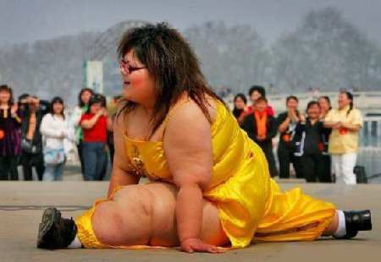

For present wishes, the past tense is used the “that” *clause*, because it indicates a situation that is only imagined and from time to time “that” is omitted.

She wishes (that) she had a diamond ring.

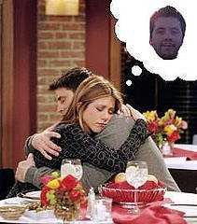

He wishes (that) he were rich. (It’s something I want now!)

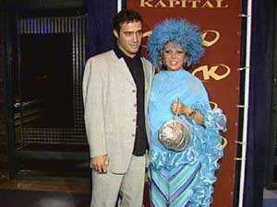

To express possibility (can) and future intention (will), use *could* and *would* respectively.

If only she could learn to sing.



They wish that she *would stop* singing.

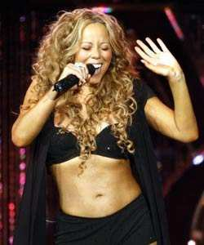

When a verb is required, the word “*were”* is used, regardless of the subject.

If only we were native English speakers.

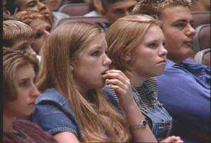

I wish (that) I were taller.



***Past wishes*** indicate things we imagine would have been different in the past, although we cannot change them. For past wishes, use the ***past perfect (had been)*** with the “that” clause.

Here are some examples:

I wish (that) I *had gone* to Cincinnati. (I had the opportunity in the past to go there, but eventually I didn’t.)



He wishes that he *had been* elected governor.



They wish they *hadn’t won* the lottery.



I was very lazy in my childhood. If only I had practiced sports.



We had to abandon the party. If only he hadn’t been so rude, we wouldn’t have abandoned the party.

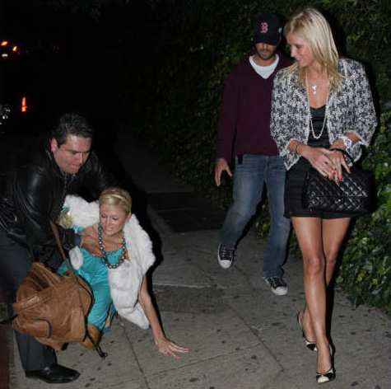

I didn’t know the answer. What a pity. If only I had known the answer.

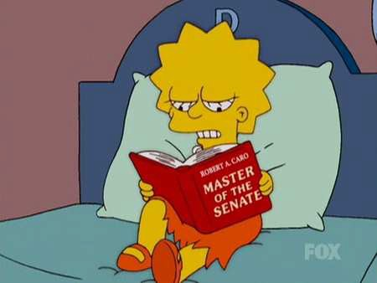

Every time you need to put emphasis on the receiver of an action, instead of the performer, we invert the order of the statement and put the important information at the beginning. Of course that implies some other changes in the structure of the sentence that we’ll explain right now.

This way of emphasizing is more commonly used in English than it is in other European languages such as German or French. As well as being used in everyday English, we can find this structure extensively in official documents and scientific papers.

Here are some examples:

The boy stroke the ball.

(Note: here we use the usual order of the sentence. But if we want to focus on what happened to the ball, then we begin the sentence with it and change the verb form to keep the same meaning----The ball was struck by the boy.)

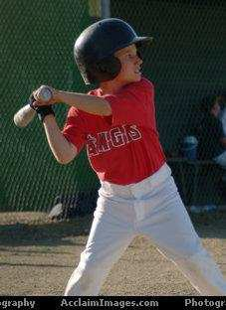

Gold has been found by the explorers.

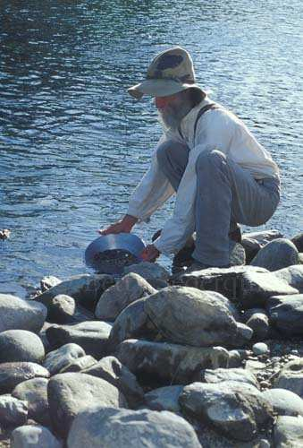

In these examples, the verbs **was struck** and **has been found** keep the same past time reference, but with different form. The subjects **ball** and **gold** refer to things receiving the actions described by the verbs.

In the following table you will find how the verbs change in order to maintain the same time reference, but to agree with different subject.

**‘To Show’**

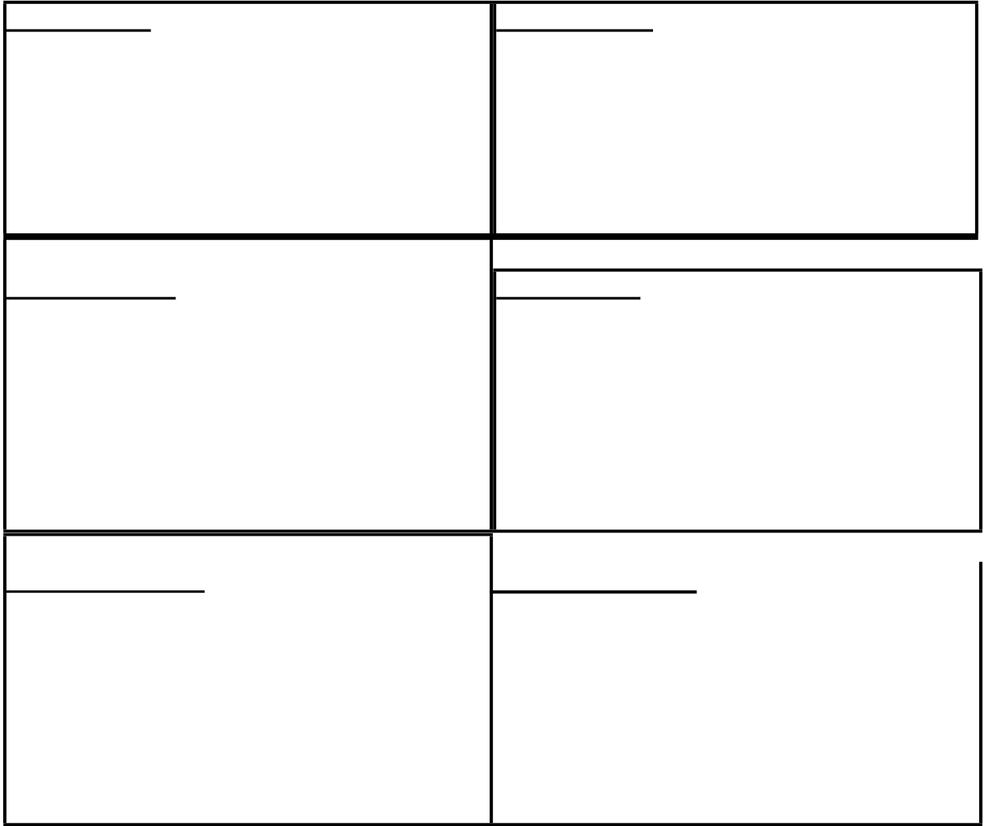

**I’m showing I have shown**

I am being shown I have been shown you are being shown you have been shown he is being shown he has been shown she is being shown she has been shown

it is being shown it has been shown

we are being shown we have been shown they are being shown they have been shown

**I was showing I had shown**

I was being shown I had been shown you were being shown you had been shown he was being shown he had been shown she was being shown she had been shown it was being shown it had been shown

we were being shown we had been shown they were being shown they had been shown

**I will be showing I will have shown**

I will (shall) be being shown I will (shall) have been shown you will be being shown you will have been shown

he will be being shown he will have been shown she will be being shown she will have been shown it will be being shown it will have been shown

we will (shall) be being shown we will (shall) have been shown they will be being shown they will have been shown

**Here are some more examples:**

**1. Present Reference:**

-He is being bathed because he is very dirty.

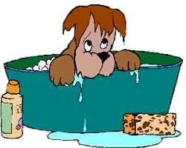

-We are being invited to a party.



-I have been attacked by some hooligans.



-She has been bitten by the love bug.



**2. Past Reference:**

-Last night, I was being followed by a strange man.



-We were being photographed (by a professional.)



-It has been said that Hillary Clinton will be the new US President in 2008.



-We have been warned about the dangers on the road.

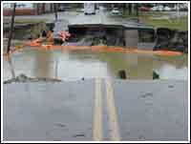

**3. Future Reference:**

-You will be being kissed by your lover



-It will be being carried to its home.

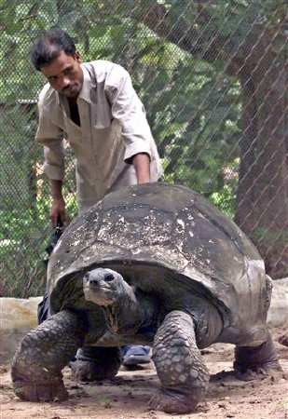

-They will have been chosen as the Oscar winners.

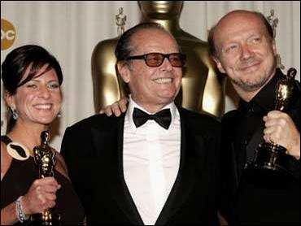

- I will have been shown the latest fashions.

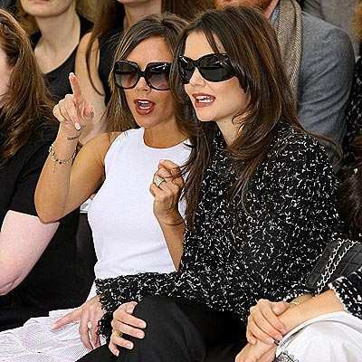

Students: Please be aware that you use this structure when you аre describing a sequence of events and you need to link these events with particles that refer to the **time.** This time references can modify deeply the meaning of the sentence. That’s why their use must be very clear. On the other hand they give you the chance to be very specific about the moment of the action or event and avoid confusions. Have a look:

1. Describing a sequence of events using “when”:

Example: “I have been working on my project, but when I am finished I

will have beer!”

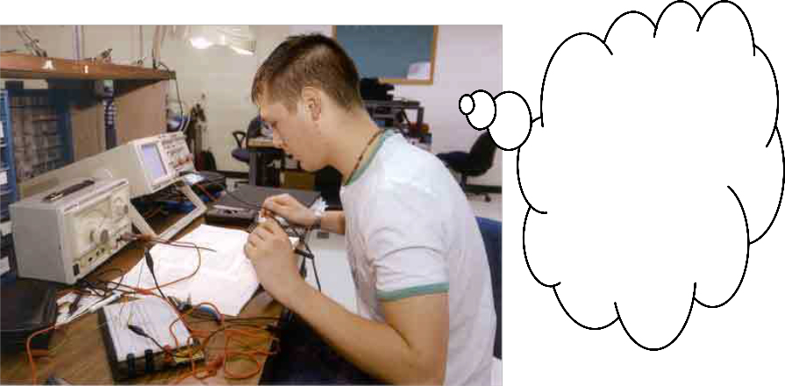

I have been working on my project, but when I am finished I will have beer!

Note: When we talk about the future, we use either a present tense (normally he

present simple) or the present perfect after the link words when, as soon as, once, after, before while, by the time, until (till), We don’t use *will*.

When I leave school, I’m going to train as a teacher. (NOT When I

will leave)

qualified)

After I’ve qualified, I’ll probably teach. (NOT After I will have

BUT: When we use “when” as a question word, it can be followed by “will” or “going to”.

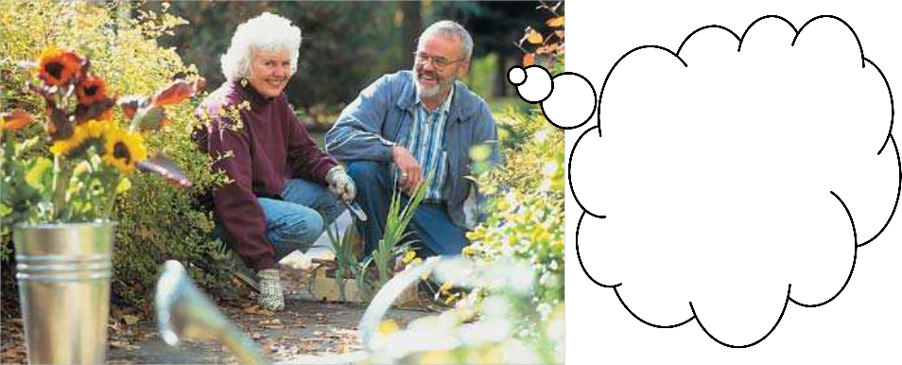

2. Describing a sequence of events using “as soon as” (=when): Example: “She has been gardening all day, but as soon as she

finishes she will watch T.V.!”

She has been gardening all day, but as soon as she

finishes she will watch T.V.!

3. Describing a sequence of events using “as”:

Example: “Rick has been eating a lot, but as he reaches his limit he will stop!”

Rick has been eating a lot, but as he reaches his limit he will stop!

“As” sometimes means ‘because’.

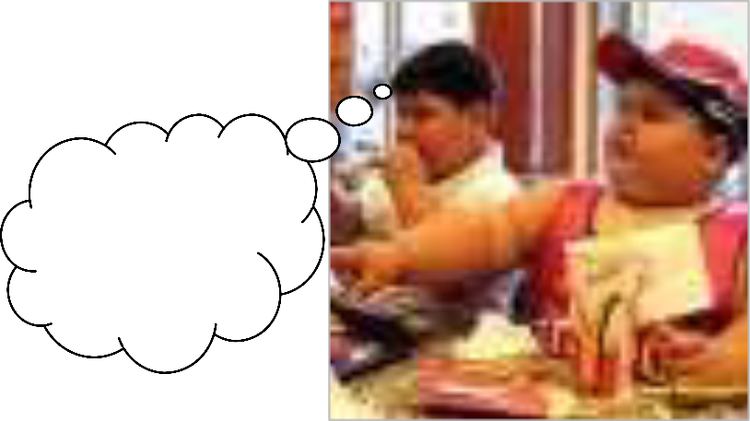

As it was a public holiday, all the shops were shut. (=because it was a public holiday)

We watched television all evening as we had nothing better to do.

“As” also is used when two things happen at the same time:

I watched her as she opened the letter (‘I watched’ and ‘she opened’ at the same time).

Can you turn off the light as you go out , please? (=on your way out

of the room)

“As”, “when” and “while”.

We use only if two things happen at the same time. We use when

(not ‘as’) if one thing happens after another. Compare “when” and “as”: When I got home, I had a bath (Not ‘as I got home’)

As I walked into the room, phone started ringing. (= at the same

time).

4. Describing a sequence of events using “while” (= during): Example: “We have been singing while our boss was out.”

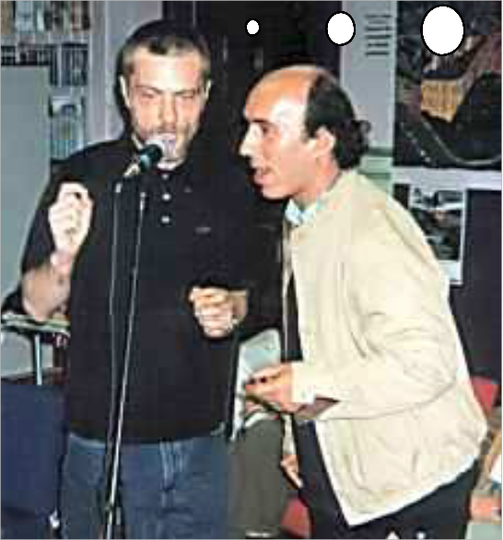

We have been singing while our boss was out.

5. Describing a sequence of events using “just as”:

Example: “An airplane crashed into my house just as closed the door.”

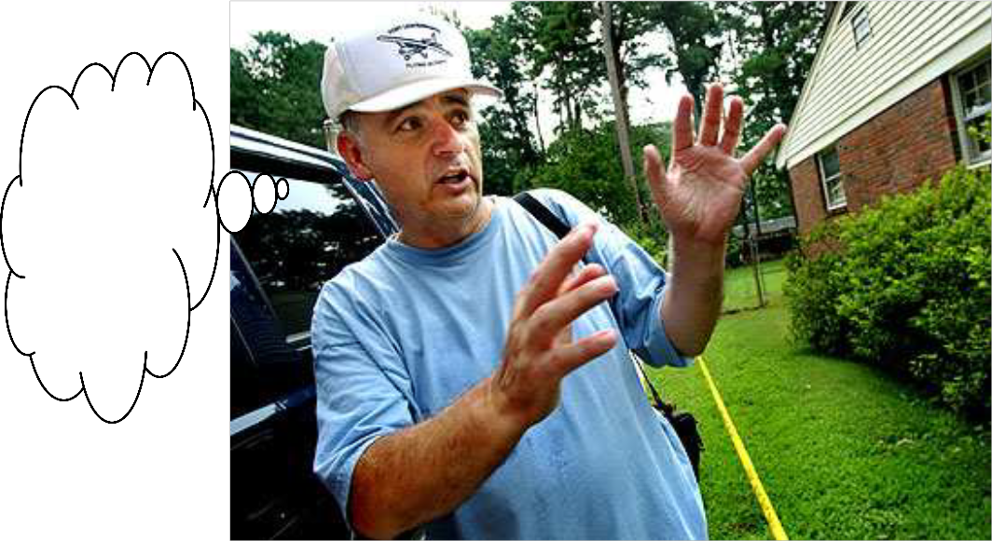

An airplane crashed into my house just as cloased the door.

6. Describing a sequence of events using “until”: Example: “She will talk until someone stops her.”

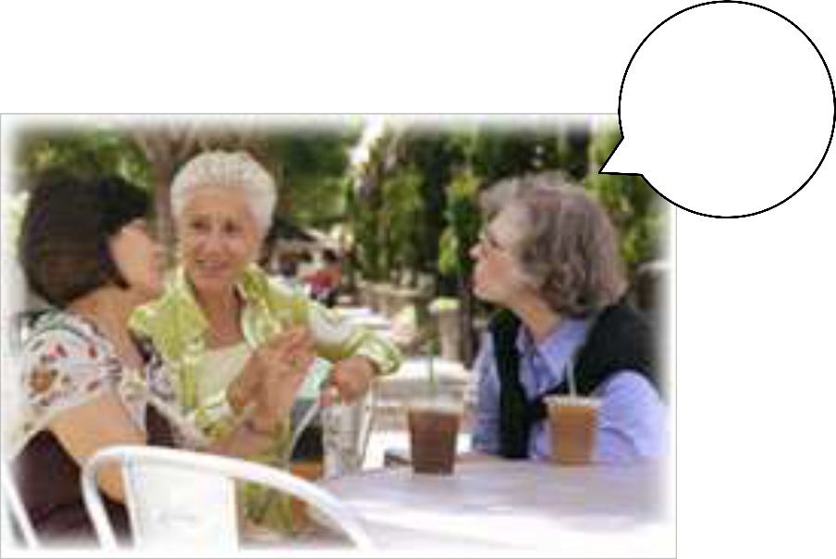

She will talk until someone stops her!

· We use “till” or “until” when we talk about an activity or a situation which continues and then stops at a particular time.

I had to work till 7.15. (=She was working before 7.15 and stopped

at 7.15.)

· “Till” is short for “until”. “Till” is more common in informal English.

7. Describing a sequence of events using “by”, “by the time”:

· “By” here is a preposition of time. It means ’not later than’

Can you be ready by 8.30?(=Can you be ready at 8.30 or before,

but not later?)

I could be ready by nine. (= at 9 o’clock or earlier, but not later)

“By” is usually followed by a time or date (5.15, June lst, etc.)

· “By” the time (that)” is a linking phrase, It’s always followed by a verb.

By the time l’ve had a bath it’ll be quarter to nine.

(= not later than the moment she finishes her bath)

Something very usual when we speak is to say or **report** other people’s words. How to do it depends on one very simple thing: when the event or action that we report takes place. Depending on that, and having in mind that we report always later in time, we have to refer to the event or action using tenses that express earlier moments (past tenses).

However, sometimes changes do not occur. Normally there is no tense change, if the reporting verb is in the present tense. This is because there is no important change of time or circumstances. However, what is said by somebody is often reported subsequently at a different time and in a different place. This change of time nearly always results in a change of tense.

**1. Reported Speech without tense change:**

Example 1: A: “I've got no idea where Australia is.”

B: “She says she's got no idea where Australia is.”

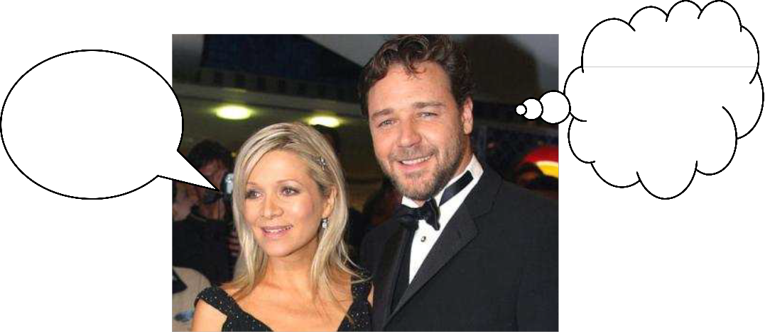

I’ve got no idea where Australia is!

She says she's got no idea where Australia is.

Example 2: A: “I haven't seen him since he came out of prison”

B: “He claims he hasn't seen him since he came out of prison.”

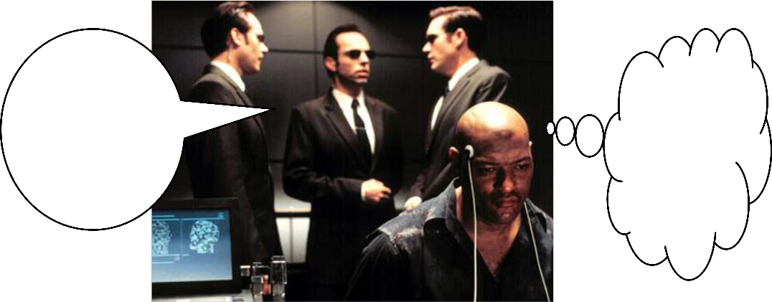

I haven’t seen him since he came out of prison.

He claims he hasn’t seen him since he came out of prison.

**2.**

**3. Reported Speech with tense change:**

Example 1: A: “Are you going to Tom and Julia's engagement party?” B: “I asked her if she was going to Tom and Julia's

engagement party.”

Are you

going to Tom and Julia’s engagement party?

I asked her if she was going to Tom and Julia’s engagement party.

Example 2: A. “Will you go to school tomorrow?”

B. “He asked me if I was going to school the following day.”

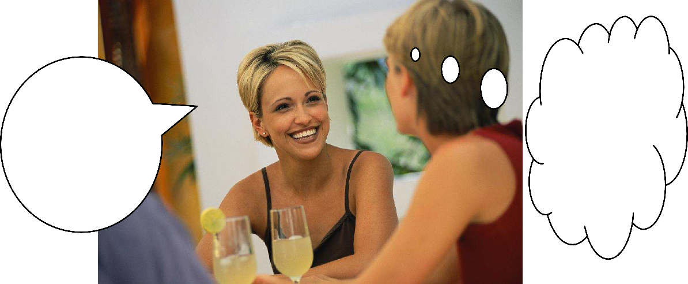

Will you go to school tomorrow?

He asked me if I was going to

school the following

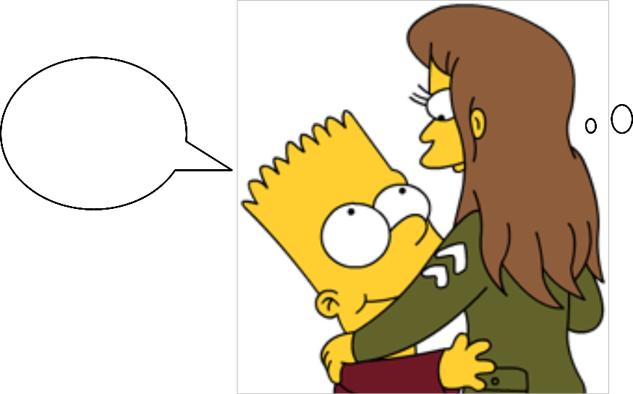

day.

Note that there are some changes you have to bear in mind when reporting somebody else’s words:

1. We can use both "say" and "tell" as reporting verbs. If we MENTION who we’re talking to, we use tell +

indirect object ( me, him, the man, etc,). We don’t put "to".

eg. "He told me it was a good car." (NOT "He told to me it was a good car.")

If we DON´T MENTION who we’re talking to, we use "say".

eg. "He said it was a good car". (NOT "He said me it was a good car".)

2. If the reporting verb is in the PAST ("He said …." "He told me …."), the verb in reported speech usually changes. It’ goes back’ one tense into the past.

DIRECT SPEECH REPORTED SPEECH

Present simple: eg. "It is a good car” Past simple: eg. "He said it was a good car". Present continuous: eg. "I’m not selling it" Past continuous: eg. "He said he wasn’t selling it". Present perfect: eg. "I´ve never had any trouble with it" Past perfect: eg. "She said she´d never had any

trouble with it"

3. The following WORDS and TIME REFERENCES also change in reported speech: DIRECT SPEECH REPORTED SPEECH

This: eg. "There´s nobody called Leach at this address" That: eg. "She said there was nobody called Leach at that address"

Tomorrow: eg. "I´ll give you the rest tomorrow" The following day OR the next day:

eg. "I said I would give him the rest tomorrow"/ the following day"

Yesterday: eg. "He left yesterday" The day before OR the previous day:

eg. "She said he´d left yesterday/ the day before" Last week : eg. "He stole it last week" The week before OR the previous week:

"They said he´d stolen it the week before" Today: eg. "He wants his car back today" That day: eg. "He said he wanted his car back

that day"

Next week/next month, etc. The following week/month, etc. Now Then

This morning/evening, etc. That morning/evening, etc.

Tonight That night

Three days ago Three days before.

When we want to report an order or request, we can use a verb like 'tell' or “say” with a to-clause. Having in mind that we report always later in time, usually we use these reporting verbs in past tense, but we keep the order or command in the infinitive (to + verb).

Examples:

A. “Go away!!!!” - He told me to go away.

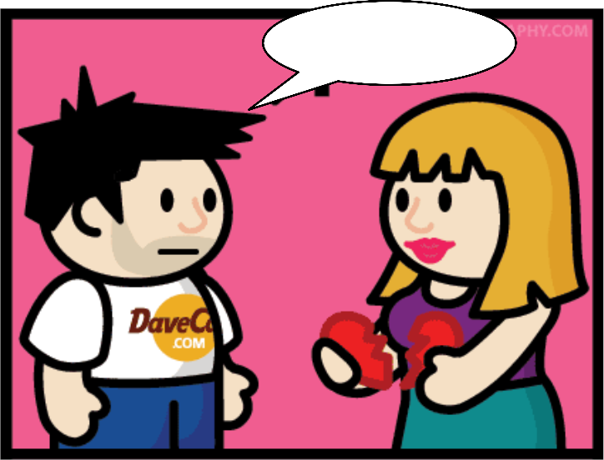

Go away!!!!

B. “Be quiet!” - She asked me to be quiet.

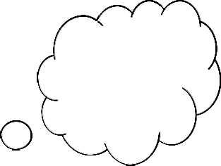

Could you please be quiet?

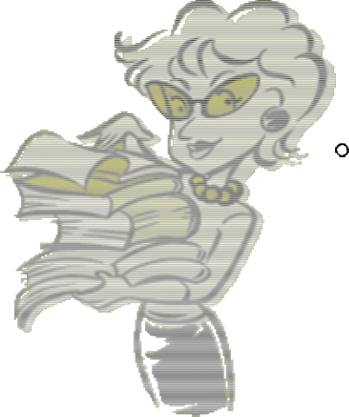

2. Requests or commands **for objects** are reported using the pattern: ask + for +

object: Examples:

A. He asked for an apple.

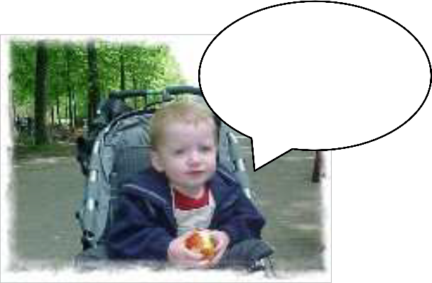

Can I have an apple?

B. He asked for another glass of water.

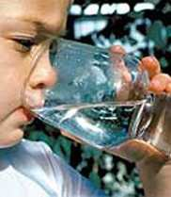

C. He asked for three kilos of onions.

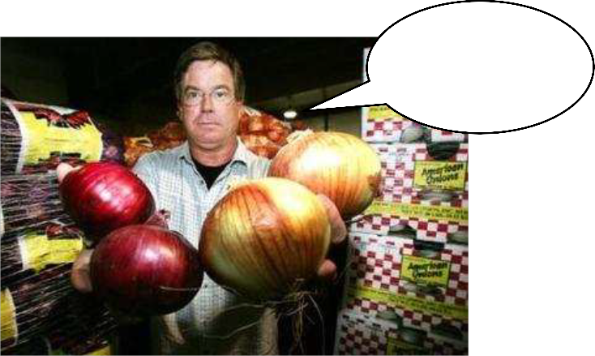

May I have another glass of water?

Could I have



3 kilos of onions?

Another way of reporting requests is using IF. After IF, the verb can change in tense or remain the same, depending on whether the request was in the past or in the moment of speaking. Have a look at the examples:

- “Can I have an apple?”

He asked if he could have an apple (e.g. yesterday) He asked if he can have an apple (now)

- “May I have another glass of water?”

He asked if he could have another glass of water (e.g. 1 hour ago) He asked if he may have another glass of water (now)

When we report someone else’s words, we do it with the help of verbs such as **tell** and **say.** But if you want to add more information to the reported part and make your speech richer, then you need to be more selective with the reporting verbs. Verbs like **inquire, deny, promise, ask, beg, suggest, explain** bring additional information and are often used when reporting a speech. So, find below a list of suggested verbs used when reporting. The rest of the structure follows the same pattern as explained in previous reported speech sections.

Look at the following examples:

1. "I didn't do it!"

He **said** that he hadn't done it.

He **denied** that he had done it OR He **denied** doing it.

**I didn’t do it!**

2. "I'll bring the book back tomorrow."

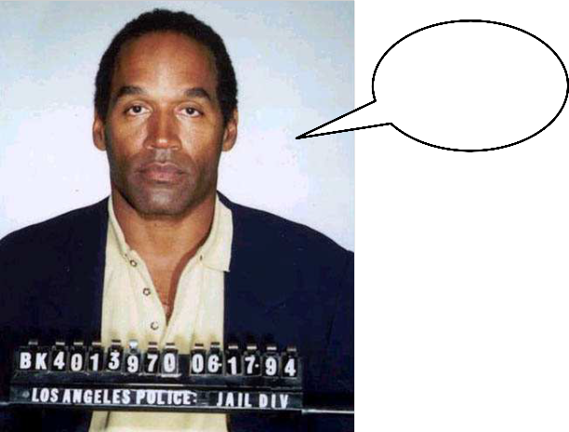

She **assured** that she would bring the book back the following day. She **promised** to bring the book back the following day.

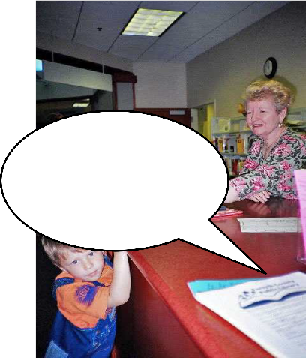

**I’ll bring the book tomorrow.**

3. "Please will you think about it some more?"

He **asked** me if I would think about it some more. He **begged** me to think about it some more.

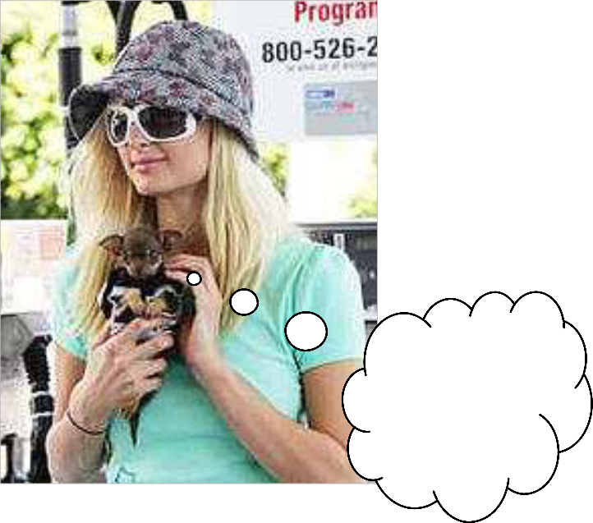

**Please will you think about it some more?**

4. "First you should put the money in the slot and then you should press the button."

She **said** that I should first put the money in the slot and then press the button.

She **explained** that I should first put the money in the slot and then press the button.

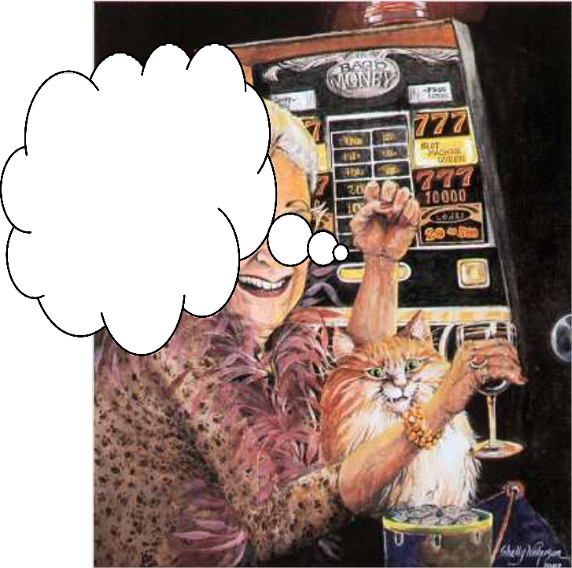

**First you should put the money in the slot and then you should press the button!**

Notice that different **reporting verbs** are followed by different structures, i.e.

**deny** + *that-clause* OR **deny** + *-ing form* **promise** + *infinitive*

**beg** + *object* + *infinitive*

Here is a list of different **reporting verbs** and their accompanying structures:

1. Verbs followed by **'*if'*** or **'*whether' + clause****:*

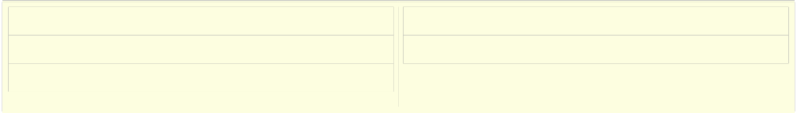

ask know remember

Say see

2. Verbs followed by a ***that-clause****:*

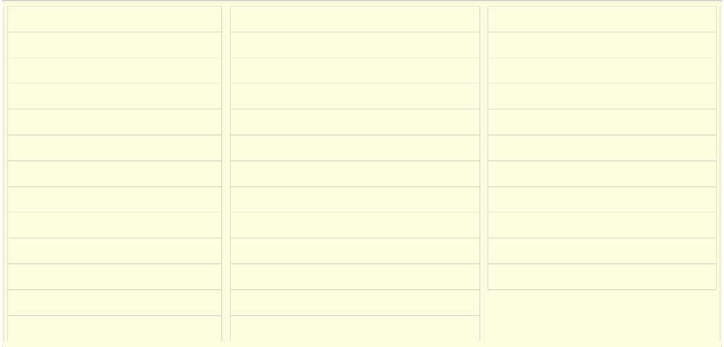

add admit agree announce answer argue boast claim comment complain confirm consider deny

Doubt estimate explain fear

feel insist mention observe persuade propose remark remember repeat

Reply report reveal say state suggest

suppose tell

think understand warn

3. Verbs followed by either a ***that-clause*** or a ***to-infinitive****:*

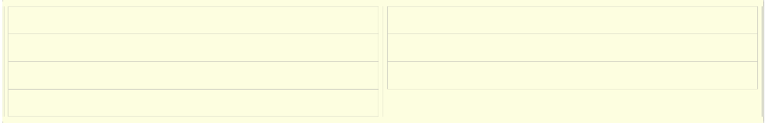

decide expect guarantee hope

promise swear threaten

4. Verbs followed by a ***that-clause containing should***

(but note that it may be omitted, leaving a subject + zero-infinitive):

advise beg demand

insist prefer propose

recommend request suggest

5. Verbs followed by a clause ***starting with a question word***:

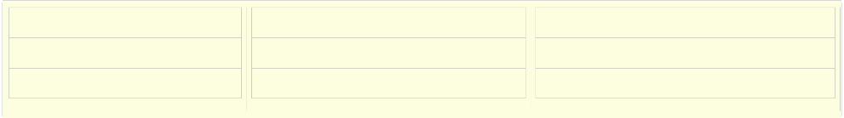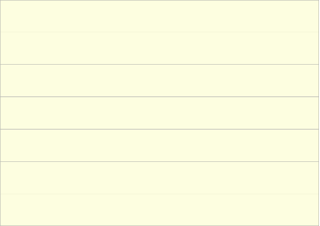

|  |  |  |
| --- | --- | --- |
| decide describe discover discuss explain forget guess | imagine know learn realize  remember reveal  say | see suggest teach tell  think understand wonder |
|  |  |  |

6. Verbs followed by ***object + to-infinitive***

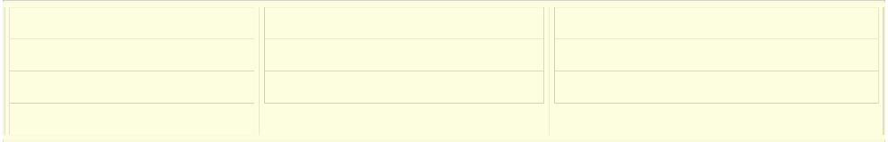

advise ask beg

command

forbid instruct invite

teach tell warn

When we report a yes/no question, we have to transpose the question and add 'if' or “whether”. In reported speech there is no question anymore, the sentence becomes a statement and it follow the word order of statements (no verb-subject change)

.

Also, there is no auxiliary (Do, does, did, etc.) and the verb tense changes as we report later in time. Thus, the verbs have past time references.

Question without question words (yes/no questions):

Peter: "Do you play football?" - Peter asked me whether (if) I played football.

Question with question words:

Peter: "When do you play football?" - Peter asked me when I

played football. Here are some more examples:

1. Can you swim?

He asked her if she could swim.

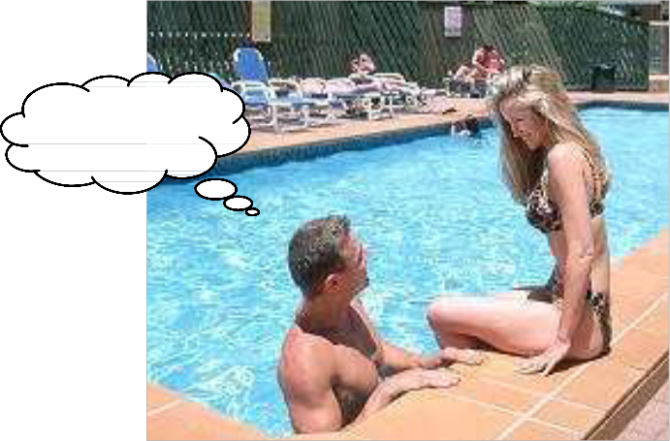

Can you swim?

2. Are you happy?

He wondered if she was happy.

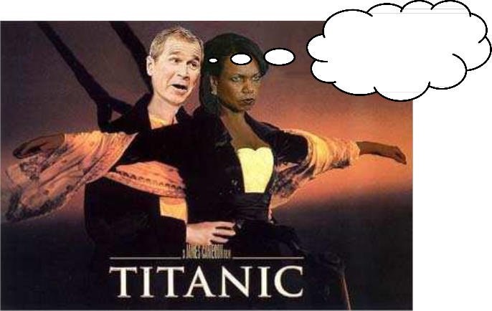

Are you happy?

3. Would you like a cupcake?

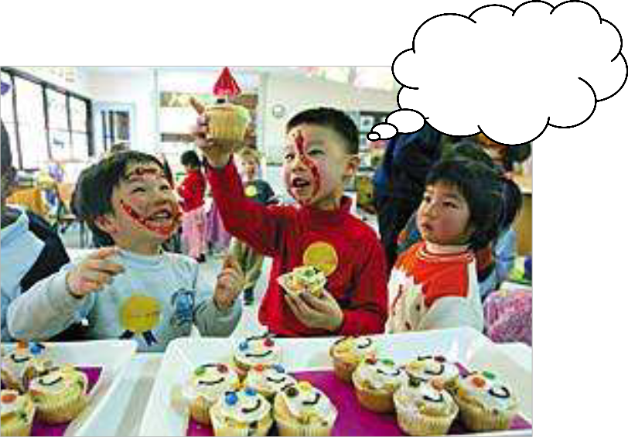

She asked him if he would like a cupcake.

Would you like a cupcake?



When we use a 'wh' question we just have to transpose the verb and subject. Here are some examples:

1. What do you want?!?!

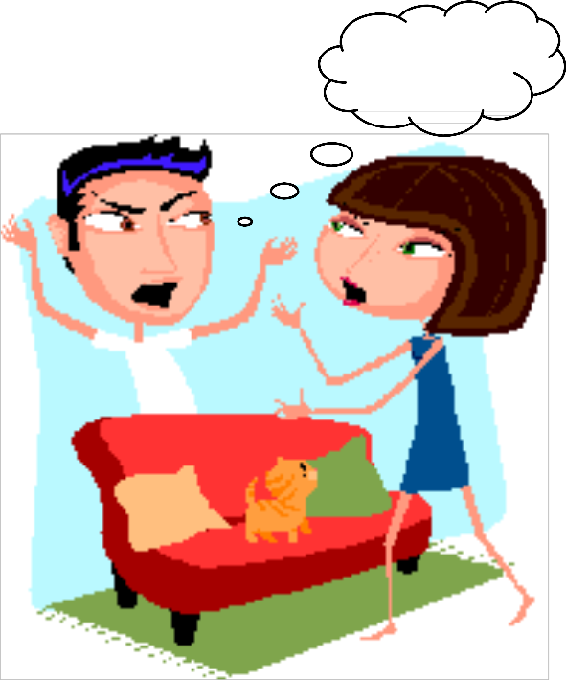

He asked her what she wanted.

What do you want?

2. Where are we going to go?

She wondered where they were going to go.

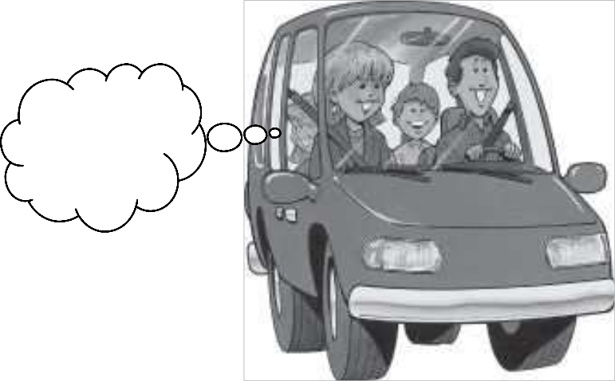

Where are we going to go?

3. How much will it cost?

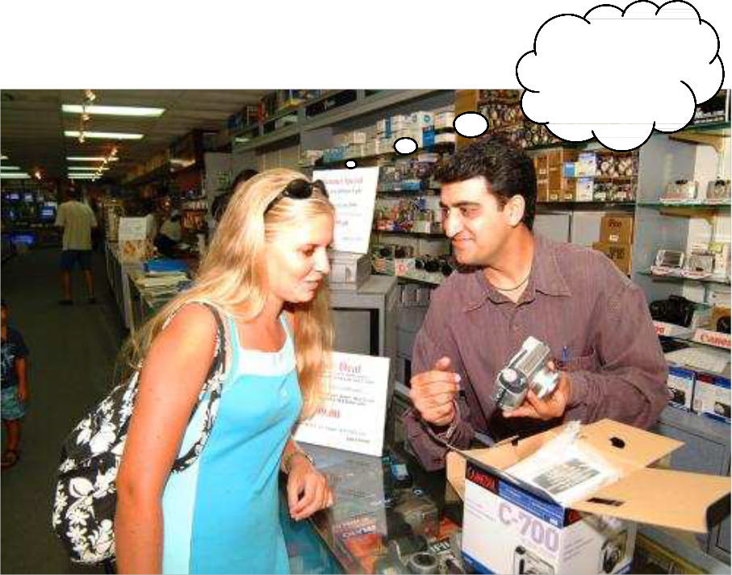

She wondered how much it would cost.

How much will it

cost?

Like previous reported speech theories, this one is no different. The only difference is that it deals with conditions and verbs that behave differently (modals) when reporting phrases.

Reported speech with modals is used to convey what someone has said, where there is often a tense change. When you use them you go one tense back.

Reported speech with conditionals is used to express an action that might take place. Here some examples:

**1.** Reported speech with **would, could, might, ought to, needn't have, must have, used to (the previous modals don’t change), can, may, must, shall, should, will, would)**

(a) “She can dance”----

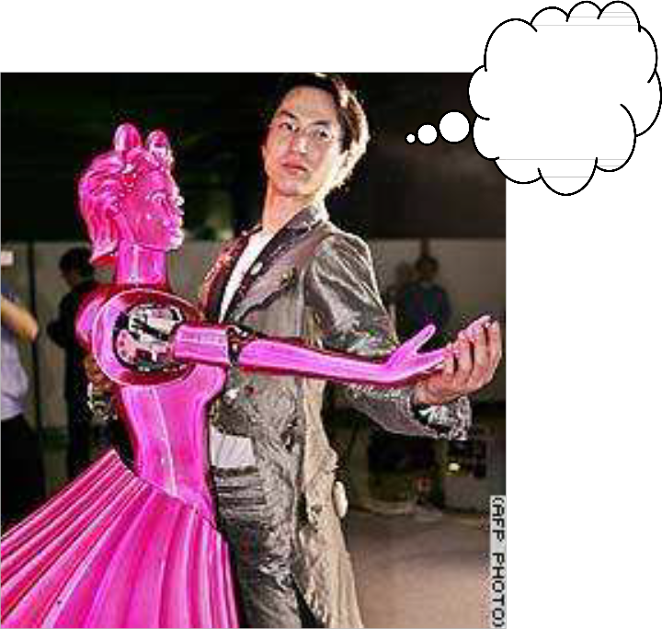

He said she could dance.

She can dance!

(b) “She must eat”---

He said she had to eat.

She must eat!

(c) “I may win the lottery”---

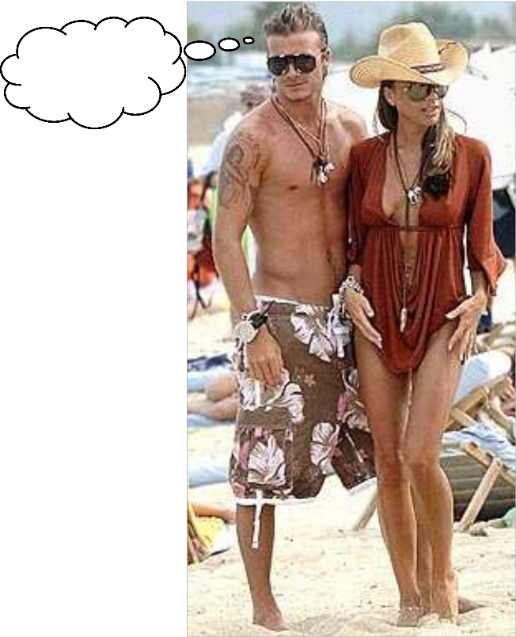

She said she might win the lottery.

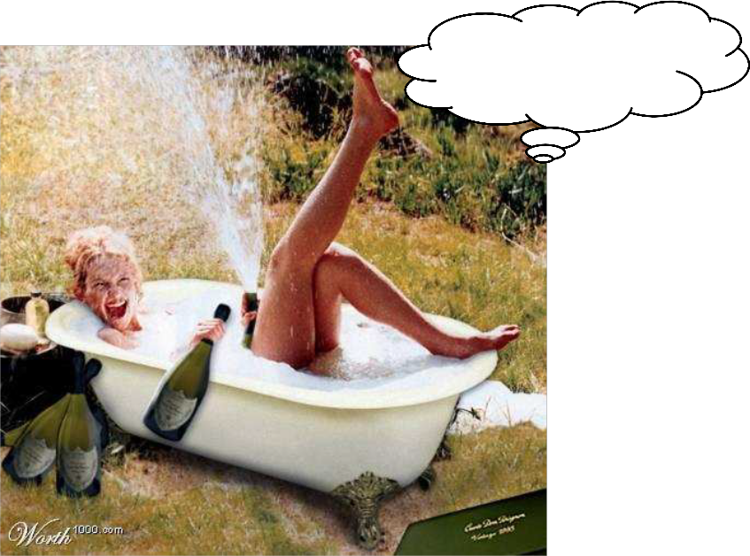

I may win the lottery.

2. Reported speech with conditionals---

(a) “She will live in California if they buy a new house” (future conditional)--- She said she would live in California if they bought a new house.

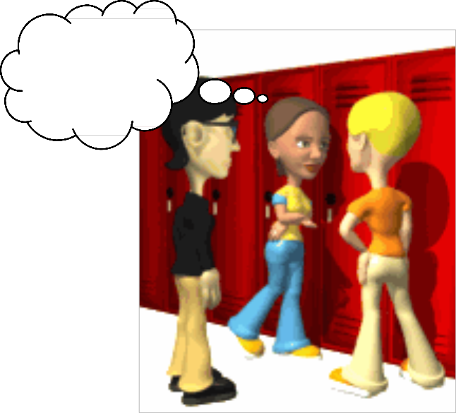

She will live in California.

(b) “I will be surfing if the weather is nice” (Future continuous –Conditional continuous)---

She said she would be surfing if the weather was nice.

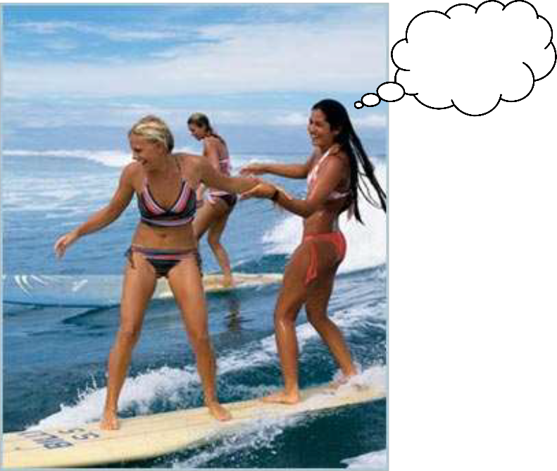

I will be surfing.

(c) “I will shop if they pay”---

She said she would shop if they paid.

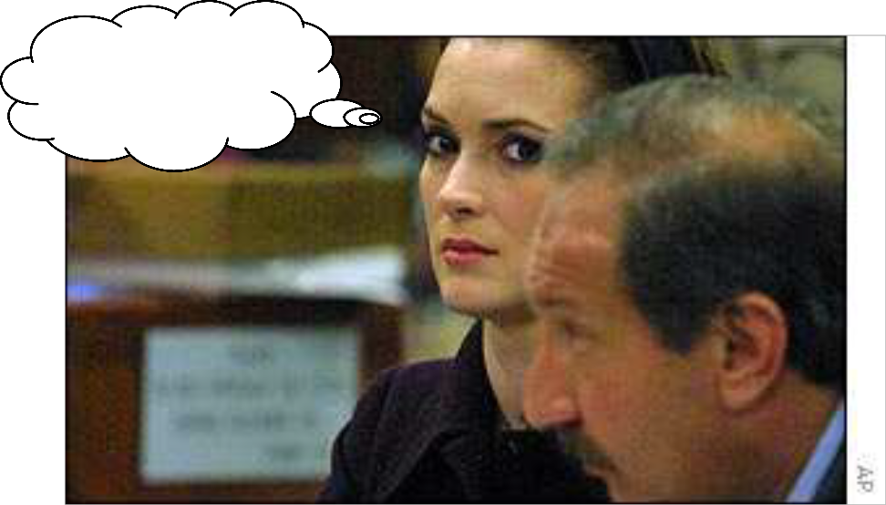

I will shop if they pay!

Summary:

When we want to give information about what people say or think we use the reported speech.

When reporting speech the tense usually changes. This is because when we use reported speech, we are usually talking about a time in the past, since obviously the person who spoke originally spoke in the past. The verbs therefore usually have to be in the past too. Example: He said: "I´m going to the cinema" - He said he was going to the cinema.

The conditionals and modals also change:

-WILL > WOULD.

E.g: She said, "I´ll teach English tomorrow"

She said she would teach English the next day.

-CAN > COULD.

E.g: She said, "I can teach English" She said she could teach English.

-MUST > HAD TO.

E.g: She said, "I must have a computer to teach English" She said she had to have a computer to teach English.

-SHALL > SHOULD.

E.g: She said, "What shall we learn today?"

She asked what we should learn today.

-MAY > MIGHT.

E.g: She said, "May I open a new browser?" She asked if she might open a new browser.

WOULD, COULD, MIGHT, SHOULD, OUGHT TO > Don´t change.

English language is characteristic by its particular spelling and pronunciation. Sometimes we use a word that sounds exactly the same as another one, but they differ either in spelling or in meaning. These two phenomena are known as homonyms and homophones. Don’t try to remember these names, just have a look at what they mean and you’ll understand their importance for the correct understanding of a message and also will help you to improve your pronunciation.

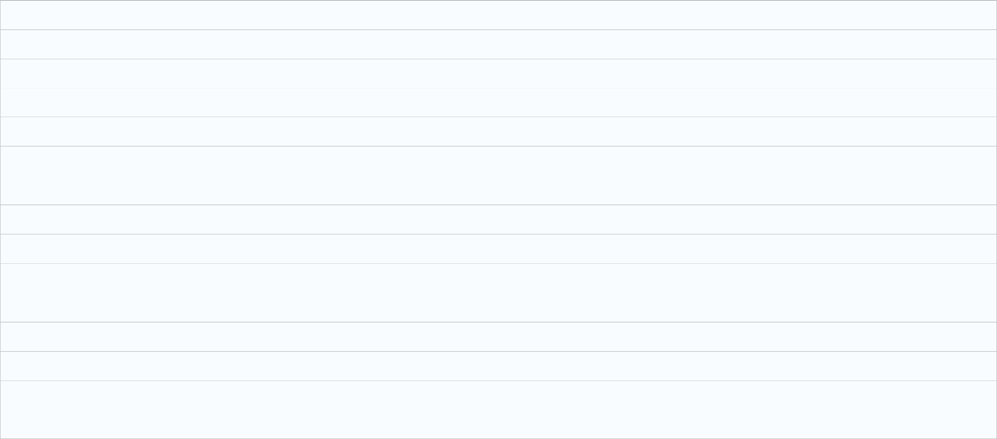

A **homonym** is a word that has the same pronunciation and spelling as another word, but a different meaning. Example: The word “stalk”, meaning either part of a plant or to follow (someone) around.

A **homophone** is a word that has the same pronunciation as another word, but whose meaning and/or spelling are different. Example: All of “to”, “too”, and “two”, or “there”, “their”, and “they’re”.

These can cause ambiguity in reading text or in hearing speech.



**Here are a few examples of HOMOPHONES (but in reality there are many):**



their: belonging to them

there: that place (opposed to here); denotes existence of something they're: contraction for "they are"

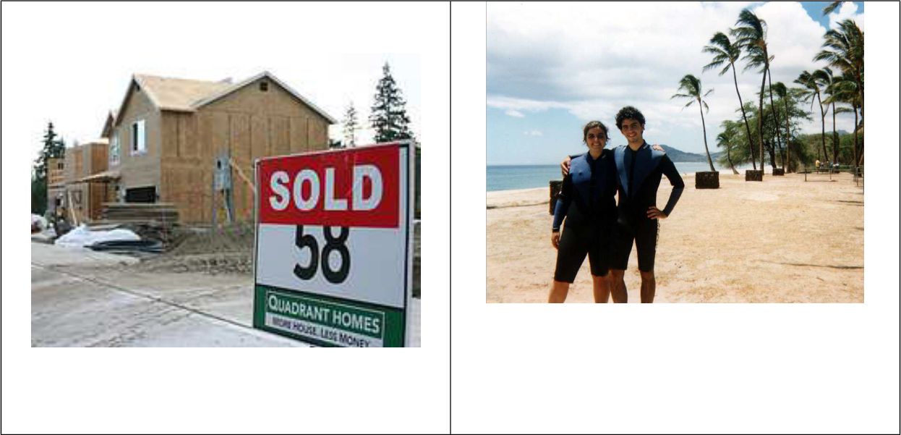

This is their home.

They live there…on the Hawaiian beaches.

They’re very happy together!



theirs: belonging to them



there's: contraction for "there is" or "there has"

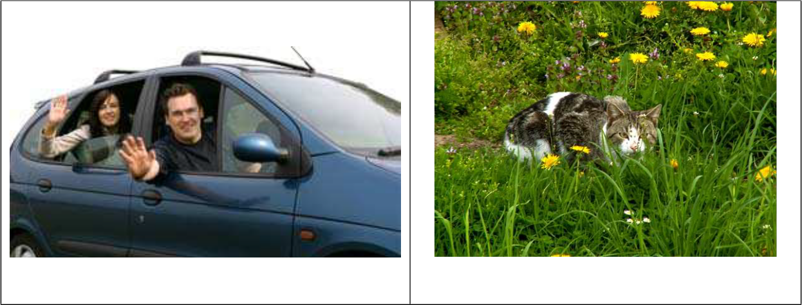

That car is theirs! There’s a cat hiding in the grass.



whose: belonging to whom



who's: contraction for "who is" or "who has"

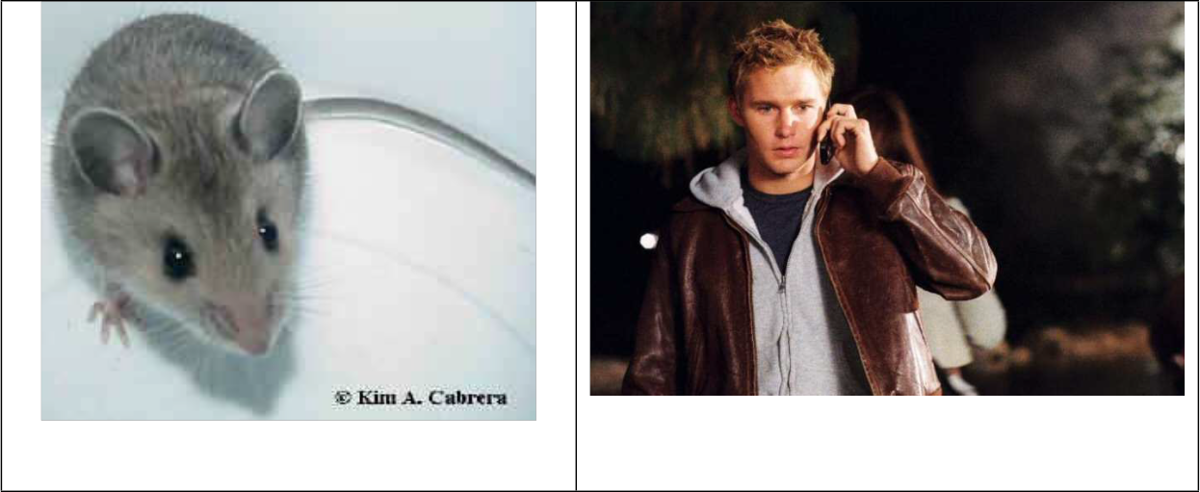

Whose mouse is that?

Who’s that cute guy?

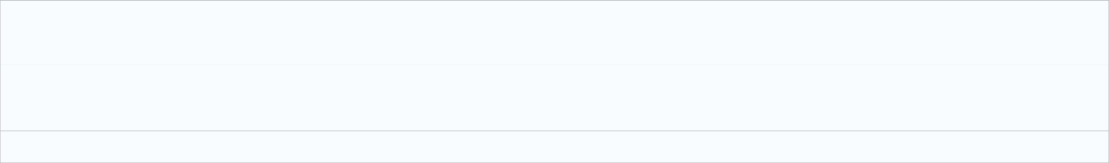

your: belonging to you (analogous to my, his, her, its, our, their)



you're: contraction for "you are" (analogous to I'm, he's, she's, it's, we're, they're)

This is your new dog!!! Happy Birthday!!! You’re looking great ladies!

(Please checkout this site for more homonyms:

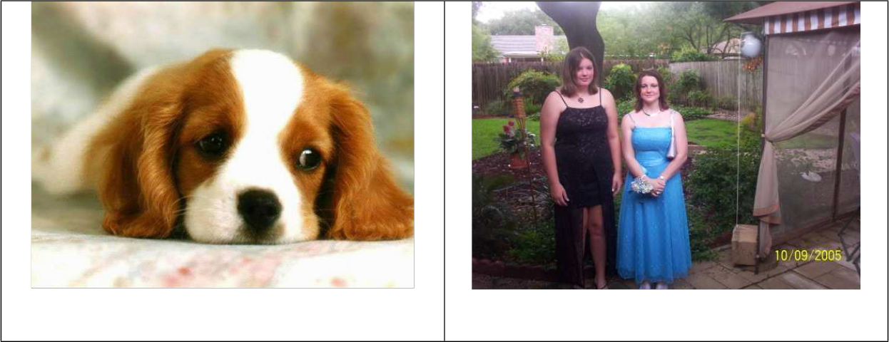

<http://en.wikipedia.org/wiki/List_of_commonly_confused_homonyms>)

1. Add, ad

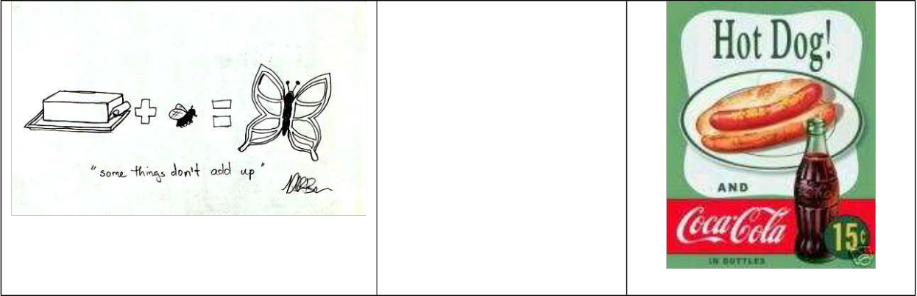

Vs.

If you add, butter and fly you get a butterfly.

This is a 50s Coke ad.

2. Carrot, carat, caret karat

|  |  |  |  |  |
| --- | --- | --- | --- | --- |
| Rabbits eat carrots | Vs. | A 20 carat ring. (English) | Vs. | 15 karat cross. (American) |

3. Hoarse, horse

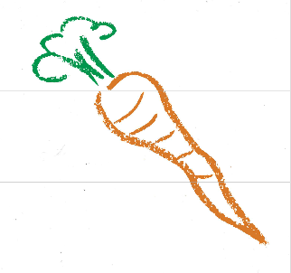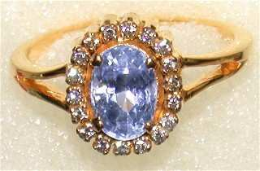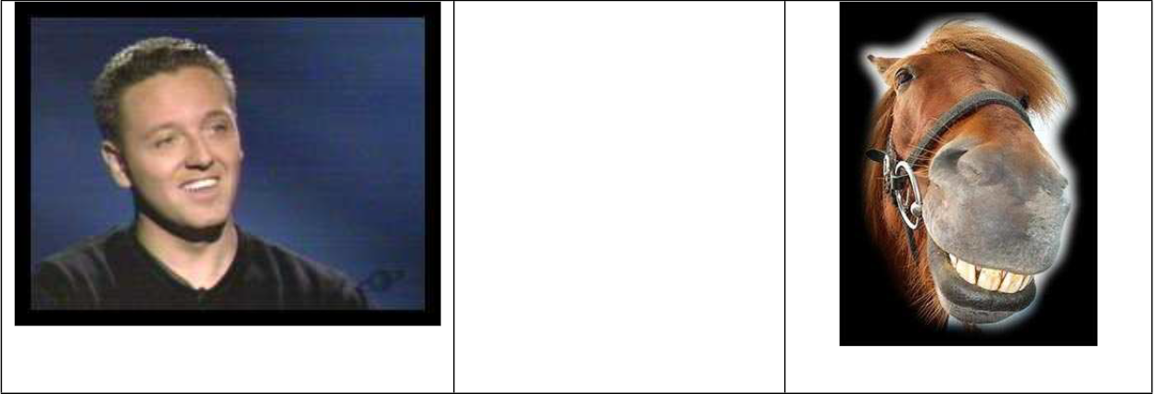

Vs.

I have a hoarse voice because I

have laryngitis, jejejej.

Hello, I’m a horse!

4. Maid, made



Vs.

Hi, my name is Nathalie and I’m a French maid.

5. Waist, waste

This toy ball is made in

China.

Vs.

I have a very small waist!

Please throw away your waste and make sure to recycle.

(Please checkout this site for more homophones: ftp://svr- ftp.eng.cam.ac.uk/pub/comp.speech/dictionaries/homophones-1.01.txt)

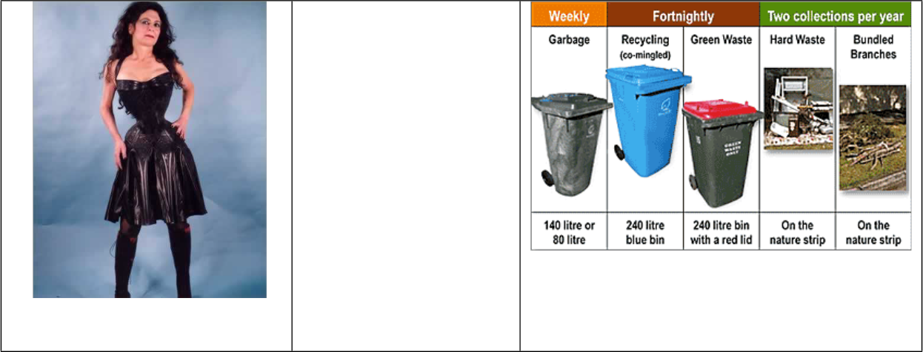

**HOMONYMS** share their spelling but have completely different meanings. Have a look at the example below with the word **BOW:**

bow - To bend forward at the waist in respect (e.g. "bow down")



bow - the front of the ship (e.g. "bow and stern")

bow - the weapon which fires arrows (e.g. "bow and arrow")

bow - a kind of tied ribbon (e.g. bow on a present, a bowtie)

bow - to bend outward at the sides (e.g. a "bow-legged" cowboy)



We can guess the meaning of the homonyms only from the context, which is usually not difficult if we understand the rest of the statement correctly.

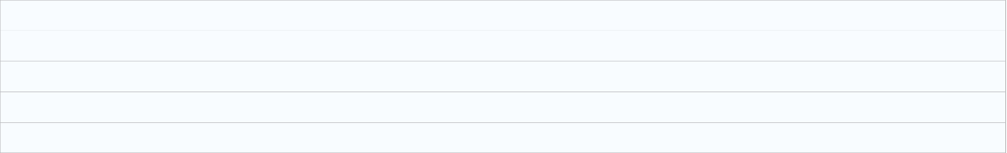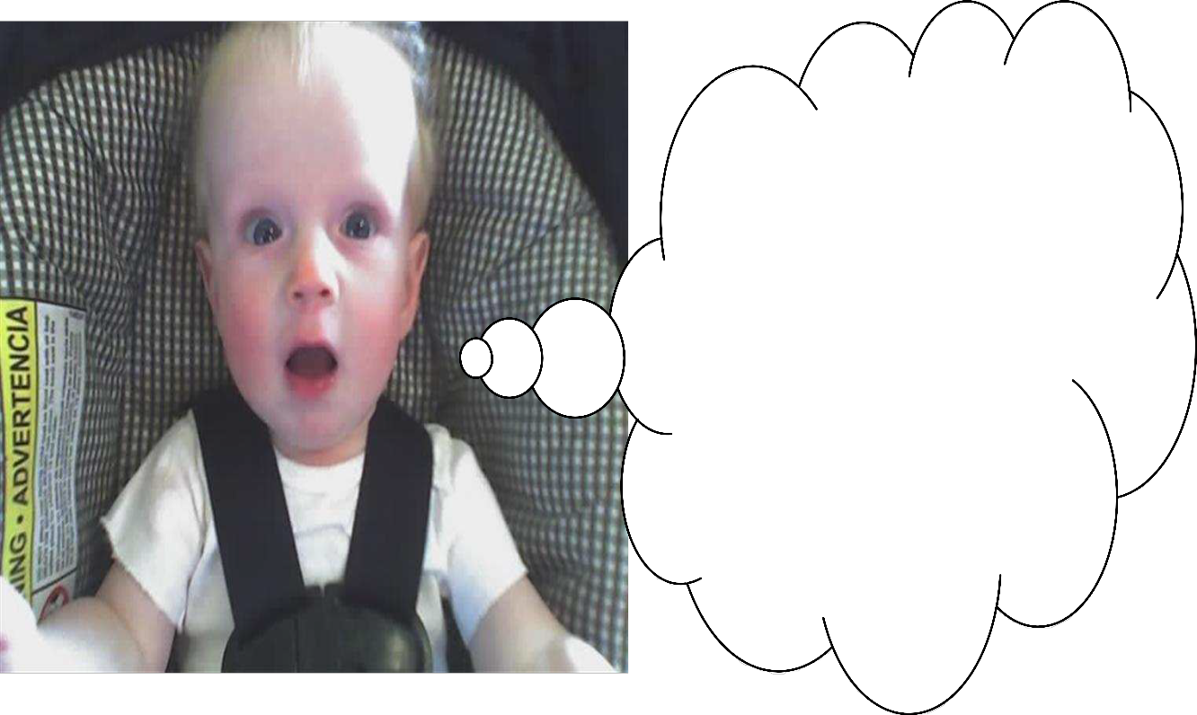

There are two very simple rules about word stress:

1. **One word has only one stress.** (One word cannot have two stresses. If you hear two stresses, you hear two words. Two stresses cannot be one word.)

2. **We can only stress vowels, not consonants.**

Sometimes the same word can change its stress but this means either that its meaning changes (e.g. the word is either a verb or a noun) or that the person that talks is either American or English (less common).



Here are some more, rather complicated, rules that can help you understand where to put the stress. But do not rely on them too much, because there are many exceptions. It is better to try to "feel" the music of the language and to add the stress naturally.

**1 Stress on first syllable**

Please pay attention for stress on the first syllable:

|  |  |
| --- | --- |
| rule | example |
| Most 2- syllable nouns | PRESent, EXport, CHIna, TAble |
| Most 2- syllable adjectives | PRESent, SLENder, CLEVer, HAPpy |

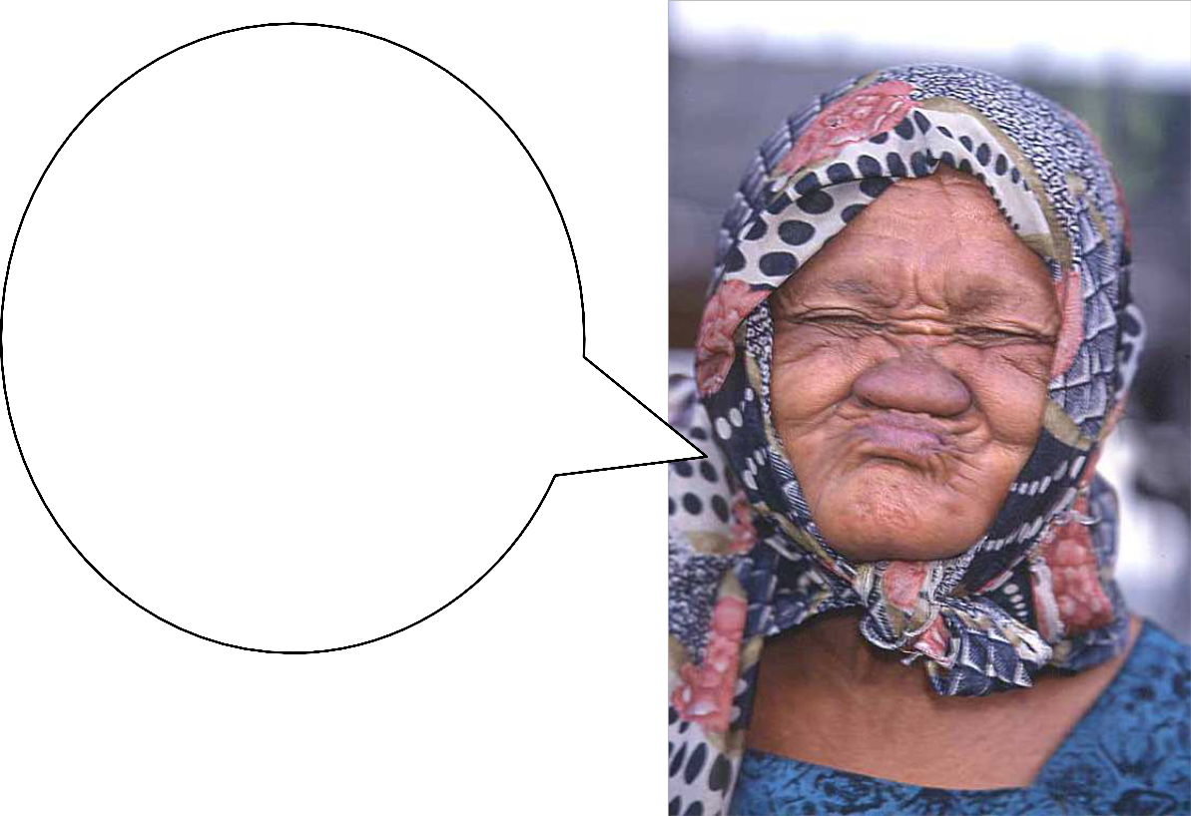

Hi cuties, here is more information for stress put on the second syllable:

|  |  |
| --- | --- |
| rule | example |
| Most 2- syllable verbs | to preSENT, to exPORT, to deCIDE, to beGIN |

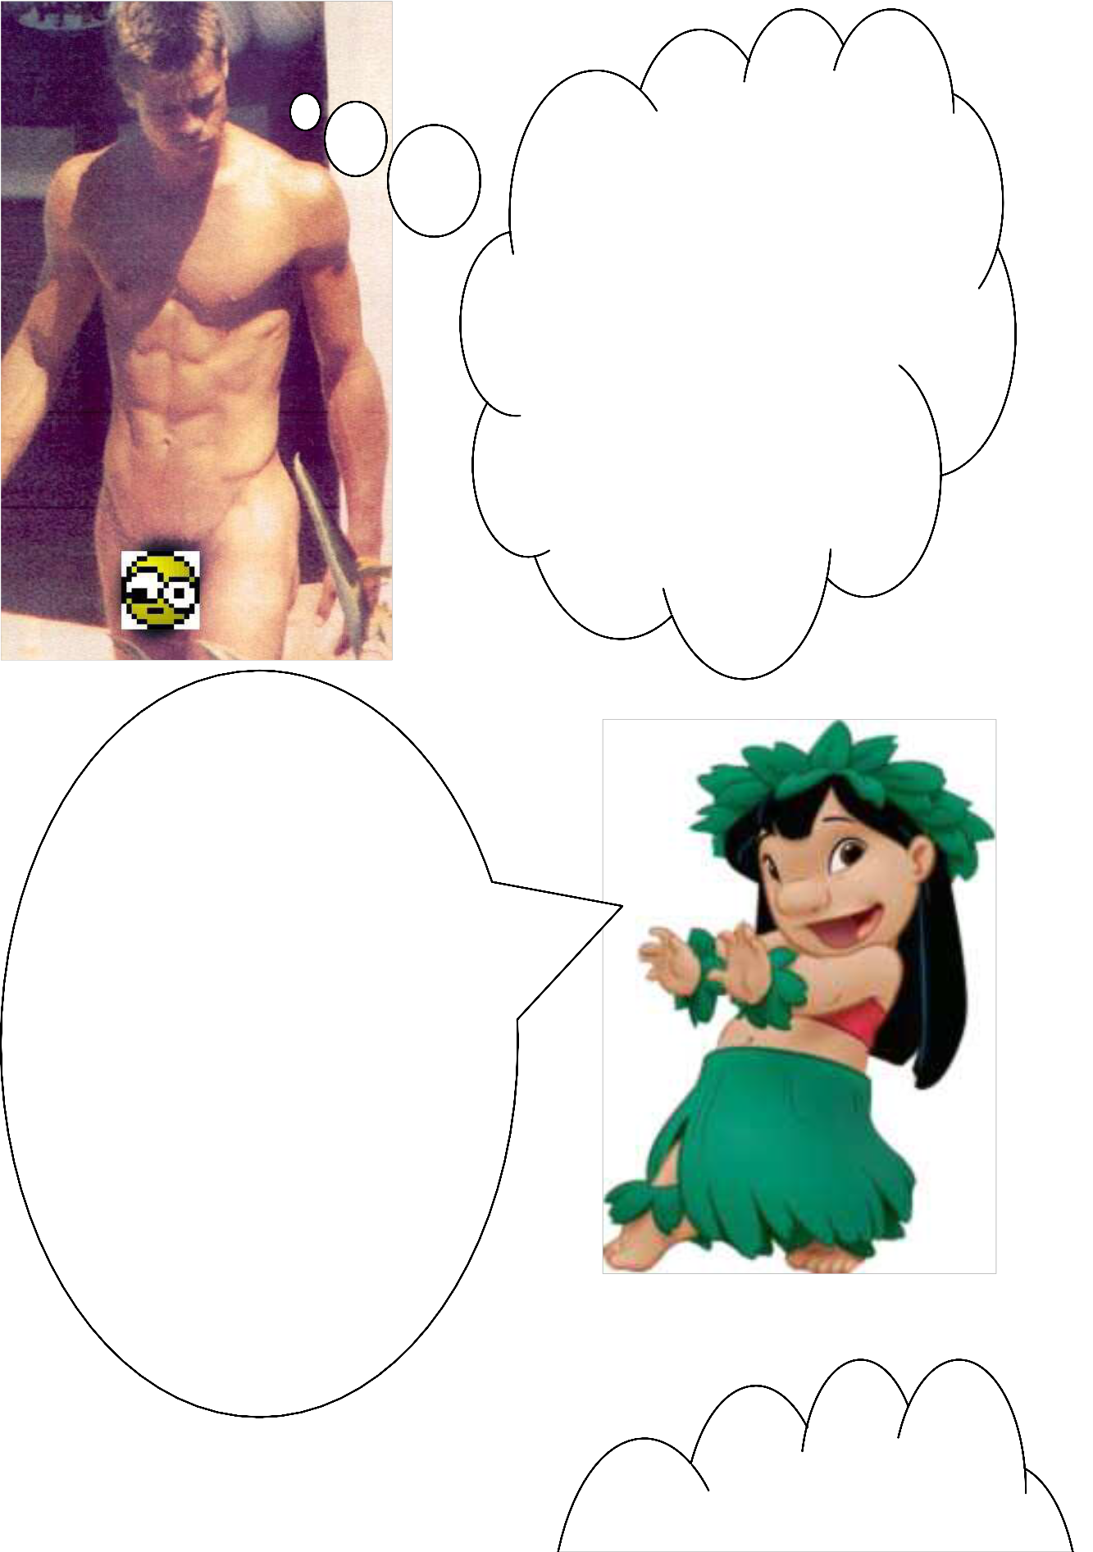

Hi sexy!!! As for the Stress on the penultimate syllable (penultimate = second from end) here is the 411:

|  |  |
| --- | --- |
| **rule** | **example** |
| Words ending in -ic | GRAPHic, geoGRAPHic, geoLOGic |
| Words ending in - sion and - | teleVIsion, reveLAtion |

Aloha! If you want to know about the stress on the ante- penultimate syllable (third from end) please make sure to read the following:

|  |  |
| --- | --- |
| **rule** | **example** |
| Words ending in  **-cy**, **-ty**, **-**  **phy** and **- gy** | deMOcracy, dependaBIlity, phoTOgraphy, geOLogy |
| Words ending in  **-al** | CRItical, geoLOGical |

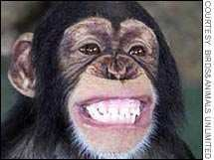

Important: Mind that in English there is a contrast of pronunciation between nouns and verbs. Some examples:

A prógress – to progréss

A présent – to presént

A prótest – to protést

A cóntract – to contráct

A rébel – to rebél

A súspect – to suspéct A cónsole – to consóle A cónflict – to conflíct

A récord – to recórd

A cónvict – to convíct

A désert – to desért

Do you know what’s the opposite of *happy?* Probably you would say that it is *sad*, and it would be true, but there is another way of expressing opposite meanings like by adding a prefix (a syllable that goes before a word and changes its meaning). Thus, we can

add *un-* to *happy* and we’ll have **unhappy**, the opposite of happy!

Prefixes can change the root of a word in many ways, and the ones below give you the opposite meaning of the word. For example: Happy---Unhappy (someone who is very sad).

The most common prefixes used to give a negative meaning to adjectives, and some verbs and nouns, are as follows:

1. Un- (it’s used with many different words)

*Friendly---Unfriendly. He is very friendly, but his girlfriend is extremely unfriendly.

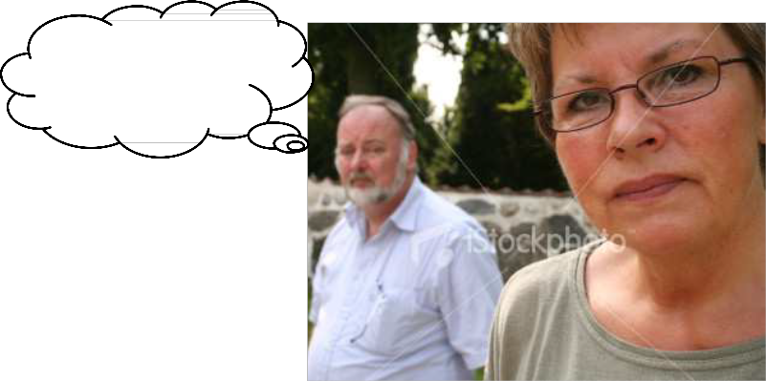

Yes, dear.

Some more examples: uncertain, uncomfortable, unsure, to undo, to undress

2. Im- (It’s used before words beginning with M or P)

*Mature---Immature. I am very mature, but my brother is very immature.

*Possible---Impossible. Its possible to earn money, but it’s impossible to save it.

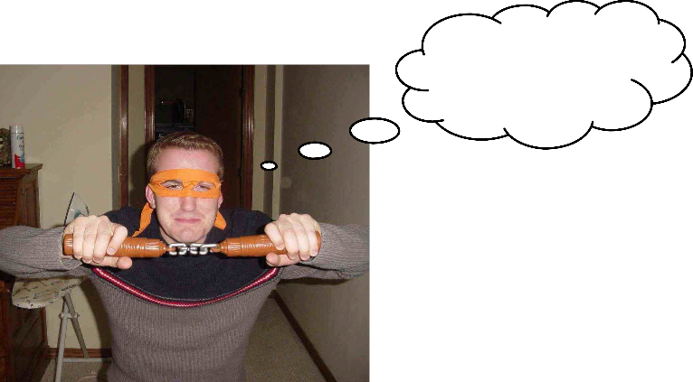

I’m a Ninja

Turtle!

3. il- (It’s used before some words beginning with L)

legible-illegible

Literate---illeterate. In general most people can read (are literate), but there are many poor people who are illeterate.

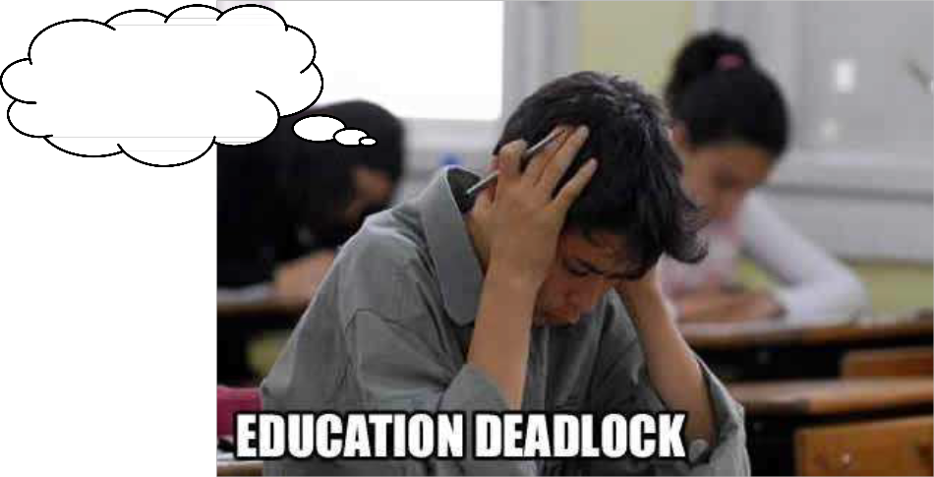

I can’t read!!!

4. ir- (it’s used before some words beginning with R)

Responsable—irresponsable. Zapatero is a responsible President, but

Bush is very ireesponsable because he started an unwanted war.

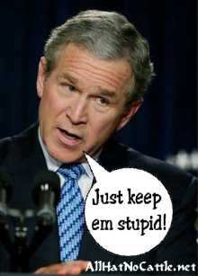

Some more examples: irregular, irrelevant

5. in- (It’s used before a limited number of words)

Visible---invisible. People are visible beings, but ghost are beings that are invisible.

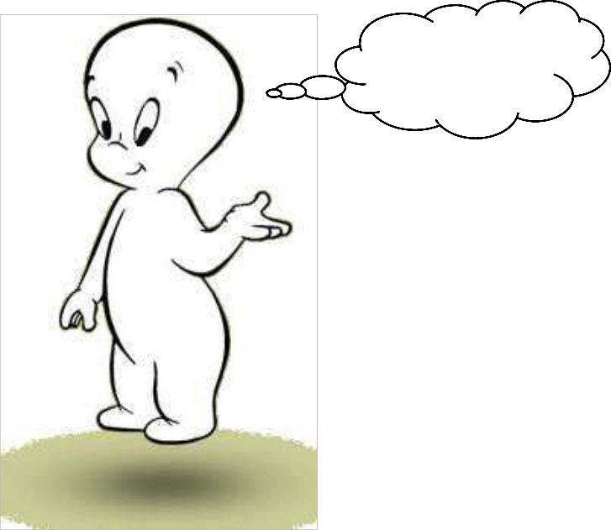

Hi, I’m

Casper. Boo!

Some more examples: incorrect, invalid

6. Dis- (used before some adjectives and a few verbs)

Like---dislike. I like Spanish omllettes, but I dislike Serrano ham.

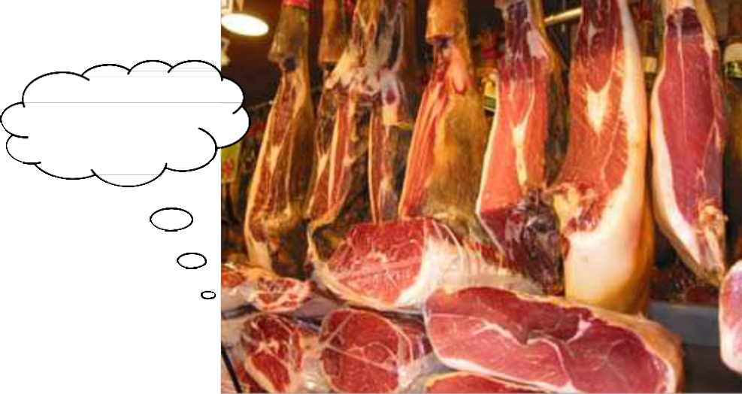

How disgusting!!!!!

A suffix is a word ending that changes the meaning of a word, e.g. walk - walking, help - helpful

You can make new words using word roots (without any prefixes or suffixes) by adding beginnings (prefixes) and endings (suffixes).

For example, 'comfort' is a root word. By adding the prefix 'dis' and the suffix 'able' you can make new words such as 'discomfort' and 'comfortable'.

Adding suffixes to words can change or add to their meaning, but most importantly they show how a word will be used in a sentence and what part of speech (e.g. noun, verb, and adjective) the word belongs to.

There are various suffixes we use. Probably the most common are 'ed' and 'ing'. Here are some other suffixes and examples.

|  |  |  |
| --- | --- | --- |
| Suffix | Example |  |
| ed | walk + ed = walked | I walk.-----Today I walked for the  1st time |
| ing | say + ing = saying | I always have something to say.--  ---I am always saying the same thing. |

|  |  |  |
| --- | --- | --- |
| Suffix | Example |  |
| er | tall + er = taller | I am tall. -----I am taller than you. |
| tion | educate + tion =  education | It’s important to educate people. --  ---Education is very important for today’s society. |
| sion | divide + sion = division | If you divide 2 by 1 you get 2. ----- |

|  |  |  |
| --- | --- | --- |
| Suffix | Example |  |
|  |  | Long division is difficult and complicated. |
| cian | music + cian = musician | Music is important to learn as a child. -----It’s difficult to be a musician because they get paid very little. |
| fully | hope + fully = hopefully | I hope FC Barcelona wins the match. -----Hopefully FC Barcelona will win tonight! |
| est | large + est = largest | The buffalo is a large animal. ----- Buffalo’s are not the largest animals in the World. |

Some other suffixes are: -ness (happy, happiness), -al (person, personal), -ary (imagine, imaginary), -able (accept, acceptable), -ly (smile, smiley), -ment (move, movement), -ful (truth, truthful), -y (ease, easy).

**Writing E-mails (formal and informal)**

STUDENTS: The basics of good email or letter writing are easy to learn. The following guide provides the phrases that are usually found in any standard email or letter. At

the end of this guide, you will find links to sites that give tips on the difficult part of writing successful emails or letters. By using these standard phrases, you can give a professional tone to your English emails or letters.

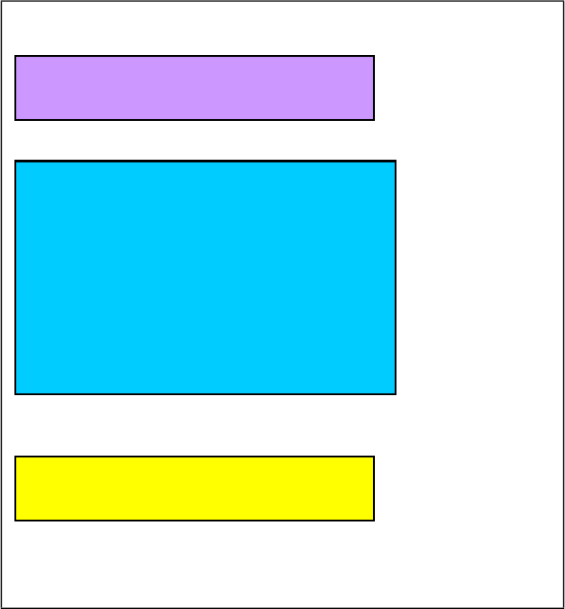

ADDRESS

BODY

SIGNATURE

**ADRESSES:**



**- FORMAL:**

1. Dear Personnel Director,

2. Dear Sir or Madam: (use if you don't know who you are writing to)

3. Dear Dr., Mr., Mrs., Miss or Ms. Smith: (use if you know who you are writing to, and have a formal relationship with - **VERY IMPORTANT** use Ms.

for women unless asked to use Mrs. or Miss)

**- INFORMAL:**

1. Dear Frank: (use if the person is a close business contact or friend)

2. Hello/hi Frank!

**BODY STRUCTURE (FORMAL AND INFORMAL) :**

**-The Reason for Writing**

I am writing to inquire about apologize for confirm

**-Requesting**

Could you possibly?

I would be grateful if you could

**-Agreeing to Requests**

I would be delighted to

**-Giving Bad News**

Unfortunately

I am afraid that

**-Enclosing Documents**

I am enclosing Please find enclosed Enclosed you will find

**-Closing Remarks**

Thank you

Hope to hear from you soon

Keep in touch

**-The Finish**

Yours faithfully, (If you don't know the name of the person you're writing to) Yours sincerely, (If you know the name of the person you're writing to)

Best wishes,

Best regards, (If the person is a close business contact or friend)

**SIGNATURE:**

**- FORMAL:**

-Use your full name, add your profession or who/what you represent, and your contact information.

For example: Jennifer Brown

Senior Vice-President of TV-3

Email: [janebrown@tv3.com](mailto:janebrown@tv3.com)

Mobile #: 675.111.000

Fax: 93.567.9887

**- INFORMAL:**

-If you are sending an email to a friend you only need to add your first name or your nickname and nothing because you are contacting them for

personal reasons, not professional reasons.

For example: Jenny

**SAMPLE LETTER:**

Dear Mr. Flintstone:

With reference to our telephone conversation today, I am writing to confirm your order for: 120 x Cheddar Deluxe Ref. No. 856.

The order will be shipped within three days via UPS and should arrive at your store in about

10 days.

Please contact us again if we can help in any way. Yours sincerely,

Kenneth W. Berry

Director of Ken's Cheese House

Email: [kenny@cheese.com](mailto:kenny@cheese.com)

Mobile #: 675.111.000

Fax: 93.567.9887



NAME: DATE: COMPANY:

1. Chose the correct sentence: It is a cat with big eyes a) It is a big-eyed cat.

b) It is a eye-biged cat. c) It is a cat big-eyed.

d) It is a large-eyed cat.

2. Complete the sentence: After a bath and a cup of tea…

a) I was relaxing. b) I felt relaxed.

c) I was entertained. d) I felt surprised.

3. Chose the correct description:

a) Penelope Cruz is a talented, small, slim, dark-haired, Spanish actress. b) Penelope Cruz is a small, dark-haired, talented, slim, Spanish actress. c) Penelope Cruz is talented, Spanish, dark-haired, small, slim, actress.

d) Penelope Cruz is a dark-haired, slim, Spanish, talented, small, actress.

4. Chose the correct sentence:

a) Spain is MUCH MORE bigger than the United Kingdom. b) Spain is FAR MORE big than the United Kingdom.

c) Spain is FAR bigger than the United Kingdom.

d) Spain is WAY MORE bigger than the United Kingdom.

5. Complete the question: At 8am tomorrow…

a) What are you going to be doing?

b) What will you be going to go?

c) What will you be doing?

d) What will you do?

6. Complete the question: By the time you are 70 years old…

a) What will you do?

b) What will you have done?

c) What will you be doing?

d) What have you done?

7. Complete the sentence: By the time I am 70 years old…

a) I have travelled the world!

b) I will like to travel the world.

c) I will have travelled the world!

d) I am going to go travelling!

8. Complete the sentence: By the time we arrived at the party…

a) They drunk all the alcohol!

b) They were drinking all the alcohol!

c) They were being drinking all the alcohol!

d) They had drunken all the alcohol!

9. Complete the sentence: When I moved to Spain… a) I have to get used to the Spanish culture. b) I would get used to the Spanish culture.

c) I had to get used to the Spanish culture. d) I get used to the Spanish culture.

10. Chose the correct ending for this question: It was a great party…

a) Is it?

b) Wasn’t it?

c) Was it?

d) Isn’t it?

11. Give the correct reaction to this statement: Tiger Woods had an affair!

a) Had he? b) Did he? c) Was he?

d) Could he?

12. Give the correct meaning of this sentence: You shouldn’t have done that!

a) You should not do it. b) You will not do it.

c) You did something right.

d) You did something wrong.

13. Give the correct meaning of this sentence: I could have gone to Cambridge University. a) It was possible but you didn’t do it.

b) It wasn’t possible and you didn’t do it. c) It was possible and you did it.

d) It was not allowed to go there.

14. Chose the correct sentence: His car has broken down. a) He needs to repairing the car.

b) The car needs to be repaired c) The car needn’t be repaired

d) He would need to repair the car.

15. Complete the sentence: If I had studied harder at school…

a) I would have done better in my exams. b) I had done better in my exams.

c) I will have done better in my exams. d) I would do better in my exams.

16. Complete the sentence: If only… a) I were more attractive… b) I was more attractive.

c) I would be more attractive. d) I will be more attractive.

17. Change this sentence: The mechanic was repairing the car. a) The car had been repaired by the mechanic.

b) The car is being repaired by the mechanic.

c) The car was being repaired by the mechanic. d) The car is repairing by the mechanic.

18. Change this sentence: The parents will clean the house. a) The house is cleaned by the parents.

b) The house will be cleaned by the parents. c) The house is being cleaned by the parents. d) The house was cleaned by the parents.

19. Complete the following sentence: I will have children…

a) When I will be older. b) When I am old.

c) When am older.

d) When I would be older.

20. Change into reported speech: “Jude Law will never win an Oscar.”

a) He stated that Jude Law will never win an Oscar

b) He stated that Jude Law would never win an Oscar. c) He stated that Jude Law won’t win an Oscar.

d) He stated that Jude Law has not won an Oscar.

21. Change into reported speech: “I haven’t stolen anything in my life.”

a) He claimed that he hadn’t stolen anything in his life. b) He shouted that he hadn’t stolen anything in his life.

c) He expressed that he hadn’t stolen anything in his life. d) He wanted that he hadn’t stolen anything in his life.

22. Change into reported speech: “Stay in your room for the rest of the day!” a) His parents said to him to stay in his room for the rest of the day! b) His parents asked him to stay in his room for the rest of the day! c) His parents begged him to stay in his room for the rest of the day!

d) His parents ordered him to stay in his room for the rest of the day!

23. Change into reported speech: “Please, please, don’t leave me!”

a) He asked he not to leave him. b) He told her not to leave him.

c) He begged her not to leave him.

d) He promised her not to leave him.

24. Change into reported speech: “Do you play the guitar?”

a) He asked me would I play the guitar. b) He asked me could I play the guitar. c) He asked me if I played the guitar.

d) He asked me when I played the guitar.

25. Change into reported speech: “I may go to London next summer”

a) She explained that she may go to London next summer.

b) She explained that she would go to London next summer. c) She announced that she might go to London next summer. d) She announced that she was going to London next summer.

26. Which pair of words is a HOMOPHONE?

a) Waist and waste. b) War and Saw.

c) Hear (with your ears) and here (the place)

d) See and saw.

27. Which pair of words is a HOMONYM?

a) Saw and saw. b) War and wore. c) Cool and Rule. d) Maid and made.

28. What is the opposite of MATURE?

a) Dismature b) Inmature. c) Unmature. d) Immature.

29. If you an honest person, you are…

a) Truthless b) Truthness c) Truthly

d) Truthful.

30. If something is not real, it is…

a) Imaginable b) Imagine

c) Imagineful d) Imaginary.